
Brooklyn Hill Cycleway
Economic Analysis
Final v2

Prepared for: Wellington City Council
Prepared by: MRCagney (NZ) Ltd

Document Information
Project Name | WCC Brooklyn Hill Cycleway Economics
Status | Final v2
Client | Wellington City Council
MRC Reference | NZ3449

Quality Assurance Register
Issue | Description | Prepared by | Authorised by | Assured by | Date
1 | Draft Report | SM |  | RLG | 11 August 2025
2 | Draft Report v2.0 | SM |  |  | 12 August 2025
3 | Draft Report v2.1 | SM |  |  | 13 August 2025
4 | Final | SM | PM | RLG | 15 August 2025
5 | Final Draft v2 | SM |  |  | 1 December 2025
6 | Final v2 | SM | PM |  | 2 December 2025

MRCagney (NZ) Ltd
Level 4, 12 O’Connell Street, Auckland, 1010
PO Box 3696, Shortland Street, Auckland, 1140
New Zealand

t: +64 9 377 5590
f: +64 9 377 5591
e: auckland@mrcagney.com
www.mrcagney.com

© 2025 MRCagney (NZ) Ltd Company Number 7771198

This document and information contained herein is the intellectual property of MRCagney NZ Ltd and is solely for the use of MRCagney’s contracted client. This document may not be used, copied or reproduced in whole or part for any purpose other than that for which it was supplied, without the written consent of MRCagney. MRCagney accepts no responsibility to any third party who may use or rely upon this document.

Contents
1 Introduction 1
2 Cycleway Project Description 2
3 Assumptions Used in Analysis 4
4 Benefits Analysis 5
4.1 Improved cycling facility 5
4.2 Cyclist health 6
4.3 Safety 6
4.3.1 Cyclist safety 7
4.3.2 Pedestrian safety 8
4.3.3 Motor vehicle driver / passenger safety 9
4.4 Motor vehicle travel time 10
4.5 Mode shift benefits to other transport users 10
4.6 Changes to parking 11
4.7 Summary of monetised benefits 11
5 Cost Analysis 12
5.1 CAPEX 12
5.2 OPEX 12
5.3 Sunk Costs 12
6 Cost-benefit Analysis, Sensitivity Tests 13
6.1 Comparing costs and benefits, base assumptions 13
6.2 Sensitivity tests 13
6.2.1 Analysis period 14
6.2.2 Discount rate 14
6.2.3 Cyclist growth rate 14
6.2.4 One-time jump in cyclists 15
6.2.5 Maintenance costs (OPEX) 15
6.2.6 Construction costs (CAPEX) 15
6.2.7 Motorist time costs 16
6.2.8 Optimistic case 16
6.2.9 Pessimistic case 17
7 Summary 18

Figures
Figure 1 Cycleway location 2
Figure 2 Brooklyn Hill Cycleway catchments 3
Figure 3 Crashes along Brooklyn Rd / Ohiro Rd, 2014-2023 6
Figure 4 Cycle crashes along Brooklyn Rd / Ohiro Rd, 2014-2023, heatmap 7
Figure 5 Crashes involving pedestrians along Brooklyn Rd / Ohiro Rd, 2014-2023, heatmap 8
Figure 6 Motor vehicle crashes along Brooklyn Rd / Ohiro Rd, 2014-2023, heatmap 9
Figure 7 Location of raised crossings 10

Tables
Table 1 Brooklyn Hill Cycleway catchment statistics 3
Table 2 Summary of monetised benefits 11
Table 3 Comparison of benefits and costs 13
Table 4 Sensitivity test, analysis period 14
Table 5 Sensitivity test, discount rate 14
Table 6 Sensitivity test, cyclist growth rate 15
Table 7 Sensitivity test, one-time jump in cyclists 15
Table 8 Sensitivity test, maintenance costs 15
Table 9 Sensitivity test, construction costs 16
Table 10 Sensitivity test, motorist time costs 16
Table 11 Sensitivity test, optimistic case 17
Table 12 Sensitivity test, pessimistic case 17
Table 13 Summary of benefits and costs 18

Introduction
This report provides the results of an economic analysis prepared for Wellington City Council (WCC) of proposed permanent changes to the Brooklyn Hill Cycleway. The Brooklyn Hill Cycleway currently exists as a painted cycle lane with periodic flexible traffic delineators (“hit sticks”) and / or modular rubber cycleway separators. While most of the cycleway is in the carriageway, there are a few short sections where the cycleway leaves the carriageway and shares the footpath with pedestrians. This solution was intended to be a trial cycling project, with more permanent infrastructure in the future.
In 2023, a preferred permanent solution was proposed with a cost of approximately $6.25 million and a benefit-cost ratio (BCR) of 2.2. This solution was a raised (relative to the road surface) uphill bike lane on Brooklyn Road, a two-way separated bike lane on Ohiro Road (between the end of the trial cycle lane and Cleveland Road), a downhill bike route on Ohiro Road north of Brooklyn Road, and a host of other cycling and pedestrian improvements.
However, in the interim, changes to funding priorities resulted in the preferred option no longer being affordable. A “hybrid” option has been developed and WCC needs to confirm that this newly scoped option represents value for money.
This report details an economic assessment carried out on the hybrid option and is laid out as follows:
- Section 2 – description of hybrid option
- Section 3 – assumptions
- Section 4 – benefits analysis
- Section 5 – presentation of costs
- Section 6 – comparison of costs and benefits, sensitivity tests
- Section 7 – summary

Cycleway Project Description
The Brooklyn Hill Cycleway project’s design has been revised from the preferred permanent option to a scaled-back permanent “hybrid” option. Rather than raised up-hill cycleway that connects to the wider bike network, the new proposal reuses most of the existing cycle lane while improving safety and facility quality. The “hybrid” option also includes the following changes:
- Two raised pedestrian crossings that cross Ohiro Rd
  - One near Bretby Cres
  - One near the southwest corner of Central Park near where Ohiro Rd and Brooklyn Rd intersect
- The relocation / consolidation of two bus stops
- The conversion of some parallel parking on Helen St to perpendicular parking with more spaces.
The cycleway location is shown in Figure 1.
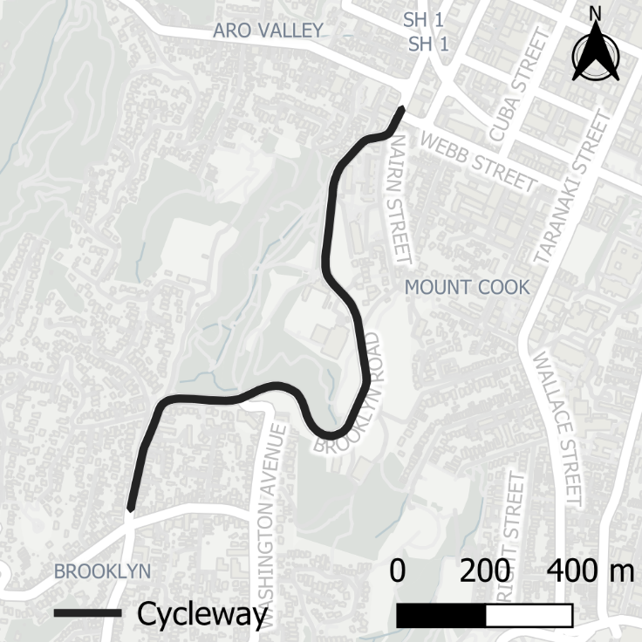
Figure 1 Cycleway location
The proposed “hybrid” option cycleway infrastructure is not as high-quality as the original permanent proposed raised cycleway. Instead of the original proposal’s raised cycleway, the hybrid proposal mainly follows the existing path and replaces the rubber hit sticks with extruded concrete separators. These concrete separators provide significantly more protection for cyclists from motor vehicles.
The hybrid option also reinstates some carriageway – straightening the cycle path in two locations – and adds some cycle markings. The hybrid option’s pedestrian crossings are raised, which slows traffic and provides additional pedestrian safety in an area with no other zebra crossings. These raised crossings will calm traffic in the area providing safety benefits to pedestrians, cyclists, and the people in cars themselves.
The Brooklyn Hill Cycleway is reasonably centrally located within Wellington. For instance, the bottom of the cycleway near Nairn St, is only 250m from Karo Dr (SH1) and 1km from Manners St. Its central location, illustrated in Figure 2, along with its catchments show that much of the city centre lies, at most, 1.6km away. This is borne out in the statistics presented in Table 1.
While the immediate 400m catchment has only an estimated 4,090 jobs and (coincidentally) the same number of estimated households, the wider catchment of 1.6km has more than 60,000 jobs, more than 47,000 residents, and more than 19,000 households. Within this wider catchment, nearly one-third of households do not own a motor vehicle which illustrates the importance of good active-mode and public transport infrastructure in the area.
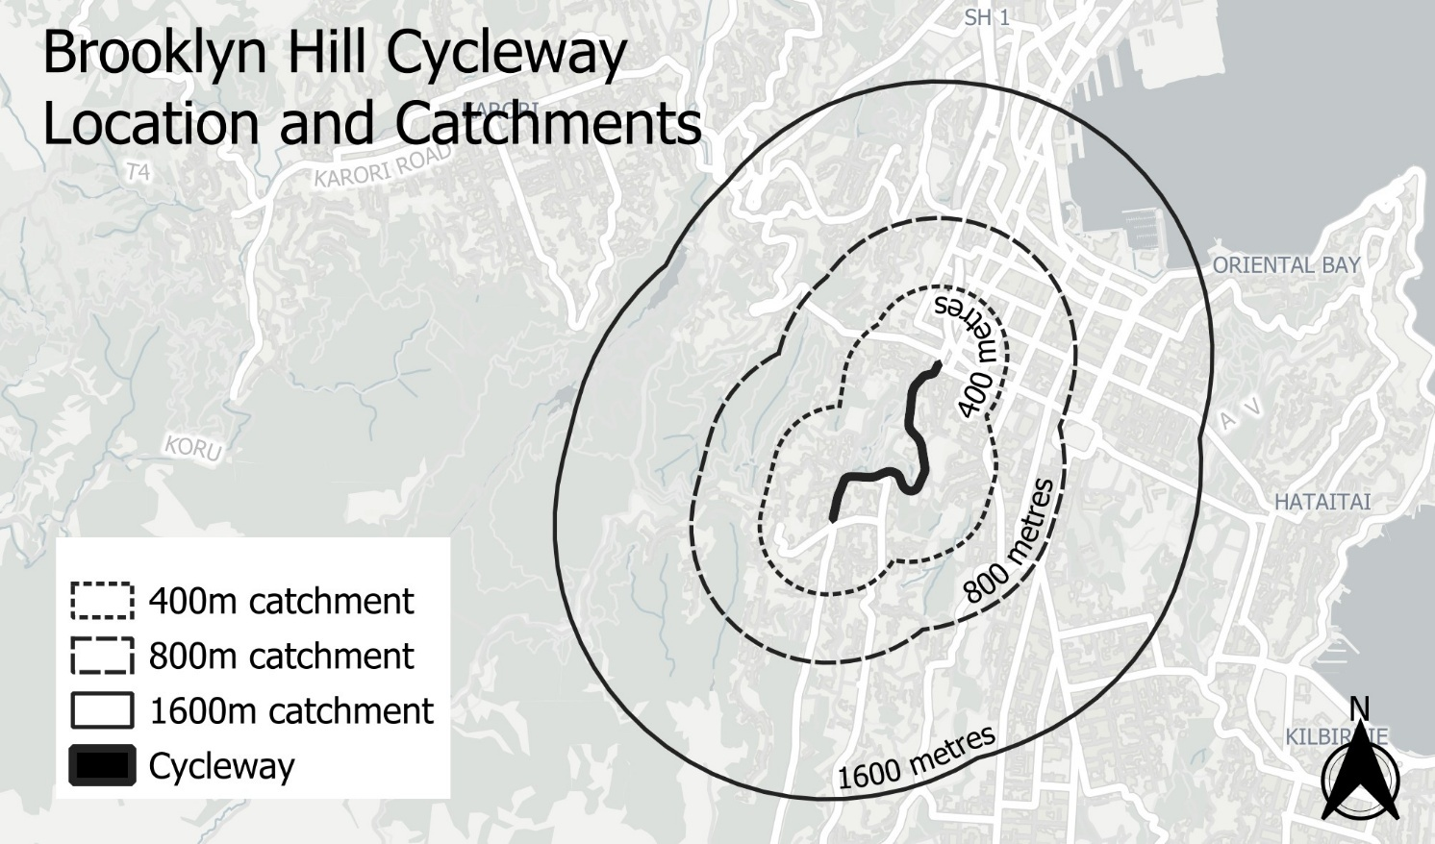
Figure 2 Brooklyn Hill Cycleway catchments

Table 1 Brooklyn Hill Cycleway catchment statistics
Catchment (m) | Jobs | Households | Households w/ no car | Residents (total) | Residents  (< 15 years old) | Residents  (≥65 years old)
400 | 4,090 | 4,090 | 1,270 | 9,600 | 730 | 770
800 | 15,510 | 9,880 | 3,580 | 23,520 | 1,480 | 1,520
1,600 | 62,530 | 19,370 | 6,030 | 47,290 | 3,240 | 3,940

Assumptions Used in Analysis
The bulk of this analysis uses methodologies from NZTA’s MBCM version 1.7.4 released in August 2025. Update factors for dollar figures come from MBCM update 2025 released in May 2025.
The following series of assumptions apply to nearly every calculation made for this analysis:
- Evaluation start year is 2025
- Construction occurs in 2027
- Evaluation period of 40 years consistent with MBCM guidance
- Discount rate of 2% for 30 years, then 1.5% thereafter consistent with MBCM guidance
- Cyclist growth rate of 3.25% per year, based on last 5 years of data
- All dollar figures are updated to be year 2024 New Zealand Dollars consistent with MBCM update factors
- Benefits begin to accrue the year after construction is complete
Input data came from various sources, as noted:
- Cycle counts come from the WCC cycle count dashboard. There is a counter that monitors bikes travelling uphill on Brooklyn Road. The counter is on the road near the entrance to Central Park.
- Vehicle counts and average speeds come from the WCC vehicle counts dashboard. There have been counts on Brooklyn Road and Ohiro Road alongside the cycleway over the past several years.
- Crash data are from NZTA’s Crash Analysis System (CAS).

Benefits Analysis
Converting the trial infrastructure, to a safer, more permanent infrastructure in the hybrid option comes with benefits. These benefits accrue to the those who are impacted by the changes. In this section, some of the benefits are monetised and others are described. The quantified benefits are:
- Improved cycling facility
- Cyclist health
- Cyclist safety
- Pedestrian safety
- Motor vehicle passenger safety
- Motor vehicle travel time (dis)benefit
Other benefits can only be described as data is unavailable, or appropriate methodologies have not been developed. These benefits are:
- Mode shift benefits to other transport users
- Changes to parking
The next several subsections describe and / or quantify these benefits in detail.

Improved cycling facility
The existing facility, as described previously, is nothing more than lines painted on the roadway, modular rubber separators, and hit sticks to demarcate the cycle lane. The proposed hybrid option, while of lesser quality than the original preferred option, does represent a marked increase in quality. It includes physical separation from vehicles (through extruded cement separators) and eliminates pedestrian kerb build outs at bus stops along the route.
Improving a cycling facility generates benefits through two different mechanisms. First, the cyclists who already ride along this route will now have a better experience. Second, the improvements often result in new people deciding to cycle.
The calculations for determining the monetary benefit of improving a cycle facility are described in the MBCM, Section 3.8. Improving the quality of a facility makes the facility more enjoyable to use. The way the calculation is formulated, it can be thought of as making the time spent cycling seem like less. That is, 10 minutes spent cycling along separated infrastructure only “costs” the cyclist as much as 5 minutes spent cycling in an area with no cycling infrastructure (e.g., down a road with no dedicated cycle lane). Therefore, in this example, the separated cycling infrastructure is worth the equivalent of 5 minutes of the cyclist’s time.
For the improved Brooklyn Hill Cycleway, we estimate that the facility quality improves by another 10% over and above the existing trial cycle facility using Table 35. Last year, there were 54,421 cyclists counted on the uphill portion of the existing Brooklyn Hill Cycleway. Given the length of the cycleway, the assumed 8kph speed of cyclists going uphill, and the number of cyclists, the present value of the facility improvements is $1.21 million.

Cyclist health
When people begin cycling, they get a health benefit. At WCC, research has shown that adding cycling infrastructure can result in a cycling uplift of 7% in the first year. Because a facility already exists, we do not assume that the uptick in cyclists will be this large. Instead, we assume that due to the increased quality of the facility, that the uptick will be 2% – significantly less than 7% but still positive to account for improved facilities.
Section 3.2 of the MBCM describes the methodology for estimating the health benefits for new cyclists and provides the value in Table 7. New cyclists receive a per-kilometre benefit of cycling – a value of $4.90 ($2021) for conventional cyclists up to a yearly cap of $6,200 and a value of $2.50 ($2021) for electric-assisted cyclists up to a yearly cap of $4,600. These figures are then adjusted to 2024 dollars using the update factors provided by NZTA.
The share of conventional cyclists to e-bikers is assumed to approximately 24% based on a survey done by WCC along Hutt Road in 2020. On average, each cycle trip is 4km according to the Household Travel Survey. Given that most cycling trips are to a destination, we assume that the average cyclist cycles 8km on a return trip (4km outbound and 4km inbound).
The distribution of how many times per week a cyclist cycles is taken from NZTA’s Simplified Procedures (SP11), worksheet SP11-5. This gives us insight into how many unique cyclists there are likely to be in the counts of cycling trips.
Given the above assumptions, the present value of health benefits to new cyclists is $2.92 million.

Safety
The hybrid option for the Brooklyn Hill Cycleway will provide safety benefits to all types of users of Brooklyn Road and Ohiro Road. CAS data shows that there have been 133 reported crashes over the past ten years along the corridor occupied by the cycleway. This is illustrated in Figure 3.
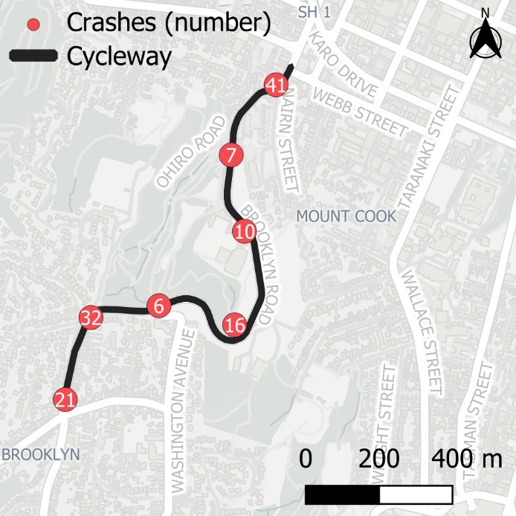
Figure 3 Crashes along Brooklyn Rd / Ohiro Rd, 2014-2023

These crashes range from those that resulted in no injuries to those that were fatal. In that time period, along this corridor, there have been 1 fatality, 10 serious injuries, and 44 minor injuries. These 133 crashes have involved 158 cars, 20 mopeds / motorcycles, 18 trucks, 17 bicycles, 10 buses, 6 pedestrians, and 33 “other” vehicles (e.g., taxis, SUVs, etc.).

Cyclist safety
As the new cycling facility will have extruded concrete separators rather than plastic hit sticks, it will offer much more protection to cyclists from vehicular traffic. The cycleway will also be wider in several places, have reduced conflict with pedestrians, and reduced conflict with parked cars.
Data from CAS indicates that over the past 10 years, there have been 17 crashes involving 19 injuries reported to CAS involving cyclists – 1 fatality, 6 serious injuries, 9 minor injuries, and 3 non-injury. A heatmap of cycling crashes is illustrated in Figure 4. Of note, the “hottest” spot on the heatmap is where traffic calming (via raised crossings) is being installed. This could be because this is an area where cyclists cross from Central Park to the cycleway or because this is the area with the most conflict.
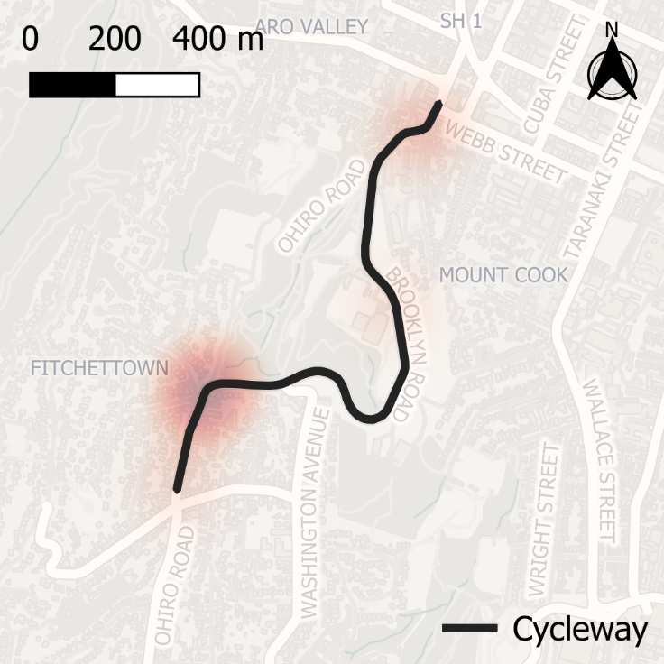
Figure 4 Cycle crashes along Brooklyn Rd / Ohiro Rd, 2014-2023, heatmap
These crash numbers are adjusted for underreporting and for observed traffic growth rates to estimate the total number of expected crashes in each category per year.
The expected crashes per year by injury category are then multiplied by the cost per crash values from Tables A28 through A31 of the MBCM (volume 2). This generates the total expected cost to society per year of crashes involving bicycles on this section of road.
A crash reduction factor of 10% was applied for the new cycleway based on Table 9-5 from NZTA’s Crash Estimation Compendium. This gives the yearly value to society of reducing crashes involving bicycles along this corridor. To get the present value of this benefit, we assumed that the crashes grow at the same rate as cyclists. The total present value of reduced crashes involving cyclists is $8.81 million.

Pedestrian safety
The proposed cycleway improvements will also have benefits to pedestrians. These will mainly be realised at the new raised crossings, though they are likely to experience safety improvements along the length of the cycleway where conflicts with cyclists will be removed.
Data from CAS shows that over the past 10 years, there have been 6 crashes reported to CAS involving pedestrians. All these crashes were reported with minor injuries. A heat map of the crashes is in Figure 5.
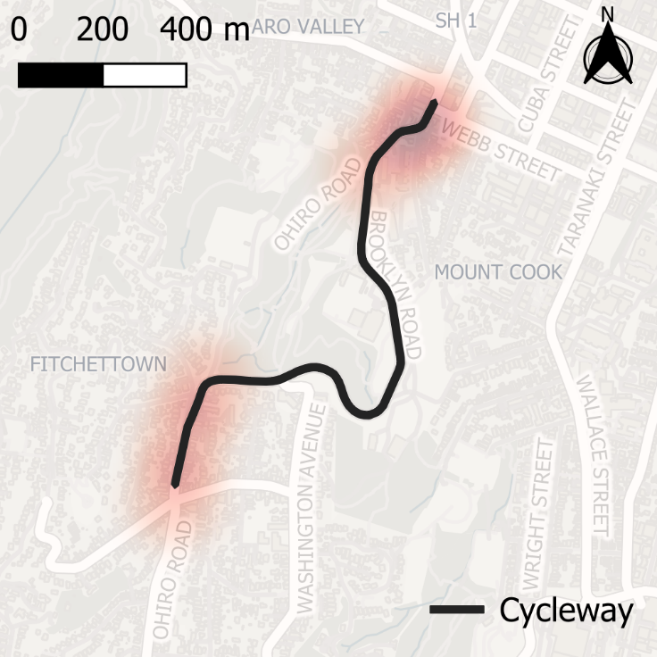
Figure 5 Crashes involving pedestrians along Brooklyn Rd / Ohiro Rd, 2014-2023, heatmap
For this analysis, we have only considered the two crashes involving pedestrians that took place near the proposed raised crossings. Like the cyclist crashes, we have adjusted for underreporting and for observed traffic growth rates to estimate the total number of expected crashes in each category per year.
The expected crashes per year by injury category are then multiplied by the cost per crash values from Tables A28 through A31 of the MBCM (volume 2). This generates the total expected cost to society per year of crashes involving pedestrians on this section of road.
A crash reduction factor of 20% was applied based on Table 9-6 from NZTA’s Crash Estimation Compendium. This gives the yearly value to society of reducing crashes involving pedestrians along this corridor. To get the present value of this benefit and to be conservative, we assumed that the crash rate does not change year to year, even as the number of cars and pedestrians grows. This is because we do not have good estimates of pedestrian growth rates along this corridor. The total present value of reduced crashes involving pedestrians is $0.40 million. If the raised crossings were not installed, the benefit would be $0.

Motor vehicle driver / passenger safety
The proposed cycleway upgrades will also have safety benefits to drivers and passengers of motor vehicles. Like for pedestrians, these will mainly be realised at the area where the raised crossings are proposed. Data from CAS indicates that there have been 111 crashes over the last 10 years involving motor vehicles (but not pedestrians or cyclists). A heatmap of these crashes is shown in Figure 6.
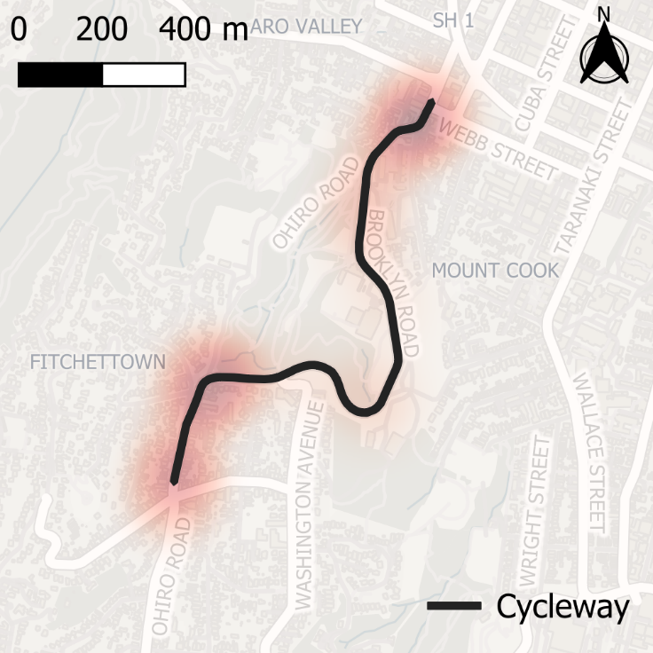
Figure 6 Motor vehicle crashes along Brooklyn Rd / Ohiro Rd, 2014-2023, heatmap
The patterns of these crashes closely follow the patterns observed for pedestrians and cyclists, though at a higher frequency. There are also a few crashes near the sharpest turn along Brooklyn Rd near Bidwell St and Washington Ave, which is not an area with apparent pedestrian / cyclist conflict.
For this analysis, we have only considered the 29 crashes involving vehicles that took place near the proposed raised crossings. Of these, there was 1 serious injury, 6 minor injury, and 22 non-injury crashes. Like with the other types of crashes, we have adjusted for underreporting and for observed traffic growth rates to estimate the total number of expected crashes in each category per year.
The expected crashes per year by injury category are then multiplied by the cost per crash values from Tables A28 through A31 of the MBCM (volume 2). This generates the total expected cost to society per year of crashes involving vehicles (but not pedestrians or cyclists) on this section of road.
A crash reduction factor of 20% was applied based on Table 9-2 from NZTA’s Crash Estimation Compendium. This gives the yearly value to society of reducing crashes involving motor vehicles along this corridor. To get the present value of this benefit and to be conservative, we assumed that the crash rate does not change year to year, even as the number of cars potentially grows. This is because we do not have enough insight into the projected growth of car traffic over time. The total present value of reduced crashes involving motor vehicles (i.e., the benefit to drivers and passengers) is $2.14 million. If the raised crossings were not built, we assume there would be no reduction in crashes, and the benefit would be $0.

Motor vehicle travel time
A potential (dis)benefit of this project is the additional time cost to motorists of driving through the area with the new raised crossings. Based on the supplied drawings, this will effectively reduce the speed of traffic for an extra 200 metres from the 30kph zone near the Brooklyn Shops on Ohiro Rd and the second raised crossing on Ohiro Rd between the Ohiro Rd / Brooklyn Rd intersection and the Ohiro Rd / Tanera Cres intersection. The location of these crossings is shown in Figure 7.
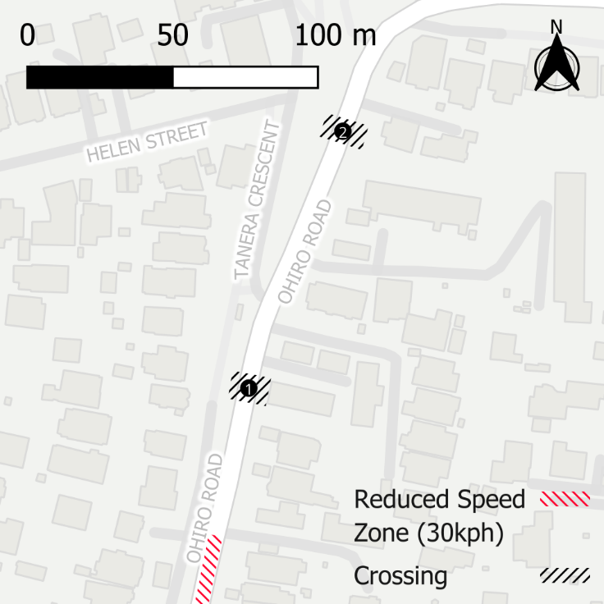
Figure 7 Location of raised crossings
A traffic survey done in 2024 near the location of the second raised crossing indicated that the average speed of travel along this stretch of road is 37kph. While this is reasonably slow, the traffic calming (raised crossing) will slow traffic further. For the purposes of this sensitivity test, we have assumed that the vehicle will slow from 37kph to 25kph at the first crossing, accelerate up to 30kph between crossings before slowing back down to 25kph for the second crossing, then continuing on their way. This is a simple, yet reasonable, proxy for what may actually happen.
Using this methodology yield an additional travel time of approximately 3.3 seconds per car. While there is an argument that this amount of time is small enough to ignore, guidance suggests that it should be counted. Using the composite value of time per vehicle from Table 16 of the MBCM and the appropriate update factors, yields a present value of negative $3.86 million for the additional travel time incurred over this stretch of road (it is additional travel time value, so is reported as a negative benefit).
In the case where no raised crossings were installed, the negative benefit would be $0.

Mode shift benefits to other transport users
Improved cycle facilities attract new cycling trips. Most of these trips would previously have been made by car (as driver or passenger), public transport, or walking. Some may be new trips, that is, trips that would not have been made at all if the improved cycle facility was not in place.
When trips that were previously made by car are switched to cycling, this provides a range of benefits. The health benefits of people becoming more active were monetised in Section 4.2. Additional benefits of people switching from motorised to non-motorised modes can include reductions in travel times and traffic congestion, reduced health impacts from harmful air pollution, and reduced environmental impacts from greenhouse gas emissions.
We have not monetised these benefits of mode shift from car to cycling. While we have estimated the number of new cycle trips resulting from this project, we do not have evidence about the reduction in private vehicle travel this could be expected to create.

Changes to parking
The proposed hybrid cycleway necessitates a few changes to parking along the route. At a high level, this is accomplished by removing some parking from the main roads (Brooklyn Rd and Ohiro Rd) and adding parking to side streets (specifically Helen St).
For this analysis, we have not monetised these changes. However, it is useful to describe the parking relocation and determine whether it is likely to meaningfully impact parking provision. From the detailed designs provided by WCC, it appears that the following changes will be made:
- 6 parallel carparks along Brooklyn Rd / Ohiro Rd removed
- Along Helen St
  - 15 parallel carparks removed
  - 33 perpendicular carparks added
This results in a net gain of 12 carparks. These new carparks are likely to be safer (off the main carriageway) and are near the two raised crossing for those who now need to cross the road to access their vehicles.

Summary of monetised benefits
In total, the present value of the monetised benefits for the hybrid option with the raised crossings is $11.64 million. Without the raised crossings, the benefits are $12.95 million, as shown in Table 2.
Table 2 Summary of monetised benefits
Benefit | Raised Crossings | No Raised Crossings
Cyclist Facility | $1,216,600 | $1,216,600
Cyclist Health | $2,922,500 | $2,922,500
Cyclist Safety | $8,812,400 | $8,812,400
Pedestrian Safety | $404,100 | $0
Car Safety | $2,137,500 | $0
Vehicle Travel Time | -$3,858,000 | $0
Total* | $11,635,100 | $12,951,500
* may not add precisely due to rounding

Cost Analysis
A project like this is made of two main types of costs. There are capital costs (CAPEX) which are mainly the construction costs and operational costs (OPEX) which, for a project like this, are mainly maintenance costs. The CAPEX tends to occur all at once at the beginning of a project, while the OPEX accrues throughout the project’s lifetime. This section of the report describes the OPEX and CAPEX for the hybrid upgrade for the Brooklyn Hill Cycleway.

CAPEX
The construction costs for this project were received from WCC and include the costs for the entire construction project. These costs include a contingency of 30%. Construction is assumed to take place in 2027. The raised crossings are expected to cost approximately $150,000 to install, so when they are not installed, that cost is omitted.
The costs received from WCC indicate that the present value of the construction costs of the project that includes the raised crossings is $2.57 million while the present value of the construction costs without the raised crossings is $2.43 million.

OPEX
For this project, the OPEX is the cost to maintain the new cycleway facility. WCC has reported that the maintenance cost of the existing temporary facility is approximately $18,000 per year. For the new facility, we have estimated that the maintenance cost per year will be 1.5% of the CAPEX (approximately $31,000). This results in a net increase in OPEX of approximately $13,000 per year. In the event that the raised crossings are not installed, this is lowered to $10,500 per year.
The total present value of the OPEX of the hybrid cycleway with raised crossings, relative to the status quo, is $0.32 million. Without the raised crossings the total present value of the OPEX, relative to the status quo is $0.26 million.

Sunk Costs
The costs in Sections 5.1 and 5.2 do not include any sunk costs. That is, any costs that have been incurred already and will have been spent regardless of whether the project goes forward have not been counted. This is standard practice as they should not bear on decision making.
From the MBCM (page 24, emphasis added):
“Sunk costs are costs that have been irrevocably committed and which have no realisable value through resale or salvage. Sunk costs that have already been incurred, such as prior investigation or design costs, must not be included in the BCR calculation”

Cost-benefit Analysis, Sensitivity Tests
In this section, the benefits from Section 4 and the costs from Section 5 are compared using our baseline assumptions. In addition, several sensitivity tests are performed so that the robustness of the analysis can be assessed.

Comparing costs and benefits, base assumptions
Using the base assumptions of the analysis yields a net present value (NPV) of between $8.74 million and $10.26 million and a benefit-cost ratio (BCR) of between 4.0 and 4.8. The details of this calculation are shown in Table 3. Based on the timings of the costs and benefits, we project the total benefits to exceed the total costs by 2036. In both cases – with and without the raised crossing – the total benefits far outweigh the total costs.
Table 3 Comparison of benefits and costs
 |  | With raised crossing | Without raised crossing
Benefits | Cyclist Facility | $1,216,600 | $1,216,600
 | Cyclist Health | $2,922,500 | $2,922,500
 | Cyclist Safety | $8,812,400 | $8,812,400
 | Pedestrian Safety | $404,100 | $0
 | Car Safety | $2,137,500 | $0
 | Vehicle Travel Time | -$3,858,000 | $0
 | TOTAL* | $11,635,100 | $12,951,500
Costs | Capital Costs | $2,574,900 | $2,430,800
 | Maintenance Costs | $321,300 | $264,900
 | TOTAL* | $2,896,300 | $2,695,600
Total | NPV* | $8,738,800 | $10,255,800
 | BCR | 4.0 | 4.8
 | Break-even year | 2036 | 2036
* may not add precisely due to rounding

Sensitivity tests
It is standard practice to sensitivity test the results of a benefit-cost analysis to changes in assumptions. For these sensitivity tests we change the assumptions for:
- Analysis period
- Discount rate
- Cyclist growth rate
- One time jump in the number of cyclists
- The scale of maintenance costs
- Construction costs increasing above the current cost estimate
- Exclusion of time costs to motorists from the raised crossings
In this analysis, we have assumed the inclusion of the raised crossings. As these have resulted in a slightly lower NPV in the previous section, this is a conservative basis on which to sensitivity test. We also include an optimistic case and a pessimistic case to give a realistic range for the scale of the benefits, costs, and BCR of this project.

Analysis period
NZTA’s MBCM recommends a standard analysis period of 40 years with options to extend out to 60 years or have a shorter analysis period. For sensitivity testing, we have examined analysis periods of 20 to 60 years. The results are shown in Table 4. This test shows that the results of the analysis are robust to the choice of analysis period.
Table 4 Sensitivity test, analysis period
 | 20 years | 30 years | 40 years | 60 years
Total Benefit | $4,477,800 | $7,747,500 | $11,635,100 | $22,230,500
Total Costs | $2,750,800 | $2,829,800 | $2,896,300 | $3,002,900
NPV | $1,727,000 | $4,917,800 | $8,738,800 | $19,227,500
BCR | 1.6 | 2.7 | 4.0 | 7.4
Break-even year | 2036 | 2036 | 2036 | 2036

Discount rate
The New Zealand Treasury, according to the MBCM, has “advised that public sector investments should be sensitivity tested using an 8% discount rate. The 8% discount rate is based on the social opportunity cost of capital (SOC) and is to be used for commercial activities undertaken by the public sector and for sensitivity testing of non-commercial activities.” For this project, we have sensitivity tested the discount rate at 8% as suggested by Treasury and 4%, which is the previous recommended discount rate by NZTA. The results of these tests are shown in Table 5.
These results indicate that the project is robust to the choice of discount rate. The main impact of using a discount rate of 8% is that the break-even timeframe is pushed out by four years to 2041.
Table 5 Sensitivity test, discount rate
 | 2% then 1.5% | 4% | 8%
Total Benefit | $11,635,100 | $7,780,400 | $4,084,500
Total Costs | $2,896,300 | $2,703,500 | $2,426,100
NPV | $8,738,800 | $5,076,900 | $1,658,500
BCR | 4.0 | 2.9 | 1.7
Break-even year | 2036 | 2037 | 2041

Cyclist growth rate
For the base scenario of this analysis, we assumed that the number of cyclists along the Brooklyn Hill Cycleway would continue to grow at 3.25%, which is the approximate year-on-year growth rate from 2019 to 2024 – even with a sharp decline in numbers during and following COVID. To ensure that the results of the analysis are robust to assumptions around the growth in cyclists, we have tested a 0% growth rate (i.e., the number of cyclists will never grow above what it is today), 1% annual growth rate, and a 7% annual growth rate. These results are shown in Table 6 and indicate that the results are robust to assumptions about the growth in cyclists.

Table 6 Sensitivity test, cyclist growth rate
 | 0% | 1% | 3.25% | 5% | 7%
Total Benefit | $5,349,400 | $6,777,400 | $11,635,100 | $17,921,100 | $29,785,200
Total Costs | $2,896,300 | $2,896,300 | $2,896,300 | $2,896,300 | $2,896,300
NPV | $2,453,200 | $3,881,200 | $8,738,800 | $15,024,800 | $26,888,900
BCR | 1.8 | 2.3 | 4.0 | 6.2 | 10.3
Break-even year | 2040 | 2038 | 2036 | 2035 | 2034

One-time jump in cyclists
Past discussions with WCC indicated that when new cycling facilities are installed, they anticipate a 7% increase in the number of cyclists. As this is not a new facility but, instead, and improvement to an existing facility, we assumed a 2% one-time increase in the number of cyclists. To test the robustness of the results to this assumption, we have also tested a 0% jump (i.e., no new cyclists because of this improvement), 1% jump, and a 4% one-time jump in cyclists. The results of this test are shown in Table 7.
These tests show that the analysis is robust to this assumption and, while the benefits are impacted, they still outweigh the costs in each case.
Table 7 Sensitivity test, one-time jump in cyclists
 | 0% | 1% | 2% | 4%
Total Benefit | $8,712,600 | $10,173,900 | $11,635,100 | $14,557,600
Total Costs | $2,896,300 | $2,896,300 | $2,896,300 | $2,896,300
NPV | $5,816,300 | $7,277,600 | $8,738,800 | $11,661,300
BCR | 3.0 | 3.5 | 4.0 | 5.0
Break-even year | 2040 | 2038 | 2036 | 2034

Maintenance costs (OPEX)
Because detailed maintenance costs were unavailable, we have assumed for the base analysis that 1.5% of the CAPEX will be the OPEX per year. That is, for every $100 in CAPEX, there will be a maintenance cost of $1.50 per year. This is only an estimate, so to sensitivity test, we have also examined rates of 1%, 2%, and 4% to provide a reasonable bound for the maintenance costs. The results from this test are shown in Table 8 and indicate the results of the analysis are robust to the assumptions around maintenance costs.
Table 8 Sensitivity test, maintenance costs
 | 1% | 1.5% | 2% | 4%
Total Benefit | $11,635,100 | $11,635,100 | $11,635,100 | $11,635,100
Total Costs | $2,638,600 | $2,896,300 | $3,154,000 | $4,184,700
NPV | $8,996,500 | $8,738,800 | $8,481,100 | $7,450,400
BCR | 4.4 | 4.0 | 3.7 | 2.8
Break-even year | 2036 | 2036 | 2037 | 2038

Construction costs (CAPEX)
The base analysis includes estimates of construction costs (CAPEX) and an included 30% contingency. To account for any additional uncertainty, we have applied an additional 30% over and above the contingency. The results of this test are shown in Table 9. These results show that the project is robust to construction cost inflation, though the break-even year shifts out to 2040.
Table 9 Sensitivity test, construction costs
 | Base | +30%
Total Benefit | $11,635,100 | $11,635,100
Total Costs | $2,896,300 | $3,900,700
NPV | $8,738,800 | $7,734,400
BCR | 4.0 | 3.0
Break-even year | 2036 | 2040

Motorist time costs
One potential (dis)benefit included in the base analysis was the additional time cost to motorists of driving through the area with the new raised crossings. As the expected additional time to each car is approximately 3.3 seconds, the idea that this will be noticeable and valuable is debateable. This sensitivity test examines the results of the analysis if these marginal motorist time costs are not considered. The results of this sensitivity test are shown in Table 10.
Table 10 Sensitivity test, motorist time costs
 | Time cost Included | Time cost Not included
Total Benefit | $11,635,100 | $15,493,100
Total Costs | $2,896,300 | $2,896,300
NPV | $8,738,800 | $12,596,800
BCR | 4.0 | 5.3
Break-even year | 2036 | 2035

Optimistic case
To assess a plausible upper bound for the BCR and NPV of this project, we have developed an optimistic case. This case includes the following assumptions:
- 60 year analysis period
- NZTA recommended discount rate
- 5% cyclist growth rate
- 4% one-time jump in cyclists
- Construction costs (CAPEX) as estimated
- Maintenance costs (OPEX) at 1% of CAPEX per year
- No additional time cost to motorists
The results of the optimistic case are shown in Table 11. This test indicates that in the plausible best-case scenario, the project would have a NPV of approximately $57.9 million and a BCR of nearly 22. This indicates that for every dollar of cost, there would be a benefit of nearly $22 gained by society. And while this is an optimistic case, it is not out of the realm of possibility.

Table 11 Sensitivity test, optimistic case
 | Base | Optimistic
Total Benefit | $11,635,100 | $57,907,600
Total Costs | $2,896,300 | $2,659,700
NPV | $8,738,800 | $55,247,800
BCR | 4.0 | 21.8
Break-even year | 2036 | 2033

Pessimistic case
Similarly, we have also developed a pessimistic case to assess a plausible lower-bound of the BCR and NPV of this project. For the pessimistic case, the following assumptions were made:
- 30 year analysis period
- NZTA recommended discount rate
- 1% cyclist growth rate
- 1% one-time jump in cyclists due to increased quality
- Construction costs (CAPEX) 30% higher than estimated (over and above contingency)
- Maintenance costs (OPEX) at 2% of CAPEX per year
- Additional time cost to motorists is included
The results of the pessimistic case are shown in Table 12. This analysis shows that even in the most pessimistic realistic case for this analysis, the project is better than a break-even proposition. This is in a case where the project generates little additional cycling, costs more than anticipated, costs more to maintain than anticipated, has a shorter analysis period, and the natural growth in cycling remains well below what has been observed.
Table 12 Sensitivity test, pessimistic case
 | Base | Pessimistic
Total Benefit | $11,635,100 | $4,421,700
Total Costs | $2,896,300 | $4,051,900
NPV | $8,738,800 | $369,900
BCR | 4.0 | 1.09
Break-even year | 2036 | 2049

Summary
This analysis of the hybrid solution for the Brooklyn Hill Cycleway indicates that the project is highly likely to be net beneficial. Even in the most pessimistic (yet plausible) case, the project is likely to be essentially break-even. Under the base set of assumptions, the project has a BCR of between 4.0 and 4.8, an NPV of between $8.7 and $10.3 million, and a break-even year of 2036 (i.e., the year in which the total accumulated benefits start to outweigh the total accumulated costs. These results are shown in Table 13.
Table 13 Summary of benefits and costs
 |  | With raised crossing | Without raised crossing
Benefits | Cyclist Facility | $1,216,600 | $1,216,600
 | Cyclist Health | $2,922,500 | $2,922,500
 | Cyclist Safety | $8,812,400 | $8,812,400
 | Pedestrian Safety | $404,100 | $0
 | Car Safety | $2,137,500 | $0
 | Vehicle Travel Time | -$3,858,000 | $0
 | TOTAL* | $11,635,100 | $12,951,500
Costs | Capital Costs | $2,574,900 | $2,430,800
 | Maintenance Costs | $321,300 | $264,900
 | TOTAL* | $2,896,300 | $2,695,600
Total | NPV* | $8,738,800 | $10,255,800
 | BCR | 4.0 | 4.8
 | Break-even year | 2036 | 2036
* may not add precisely due to rounding

https://nzta2.cwp.govt.nz/resources/monetised-benefits-and-costs-manual/
https://nzta2.cwp.govt.nz/assets/resohurces/monetised-benefits-and-costs-manual/2024-update-factors.pdf
https://www.transportprojects.org.nz/cycle-data
https://wellington.govt.nz/parking-roads-and-transport/roads/working-on-the-road/vehicle-counts
https://opendata-nzta.opendata.arcgis.com/datasets/NZTA::crash-analysis-system-cas-data-1/explore
It should be noted that we have reservations about the quality metrics in the guidance as a painted cycle lane is considered to be 80% better than no infrastructure, while improving it from a painted lane (with no protection) to a fully separated cycling facility only increases the benefit another 20%. However, for this analysis, we have used the official guidance, which means that the facility benefit is potentially underestimated.
https://www.transport.govt.nz/statistics-and-insights/household-travel
https://nzta2.cwp.govt.nz/assets/resources/monetised-benefits-and-costs-manual/Monetised-benefits-and-costs-manual-v1.7.3-volume-2-appendices.pdf
https://www.nzta.govt.nz/assets/resources/crash-estimation-compendium/crash-estimation-compendium-2nd-edition.pdf
https://nzta2.cwp.govt.nz/assets/resources/monetised-benefits-and-costs-manual/Monetised-benefits-and-costs-manual-v1.7.3-volume-2-appendices.pdf
https://nzta2.cwp.govt.nz/assets/resources/monetised-benefits-and-costs-manual/Monetised-benefits-and-costs-manual-v1.7.3-volume-2-appendices.pdf
https://nzta2.cwp.govt.nz/assets/resources/monetised-benefits-and-costs-manual/Monetised-benefits-and-costs-manual-v1.7.4-volume-1-procedures.pdf, page 25.

