Date 26th June 2026
Project/File:
310206429
Prepared for:
Wellington City Council
Prepared by:
Stantec
Updated 90% Detailed Design Stage Safe System Audit

Brooklyn Hill Cycling Improvements


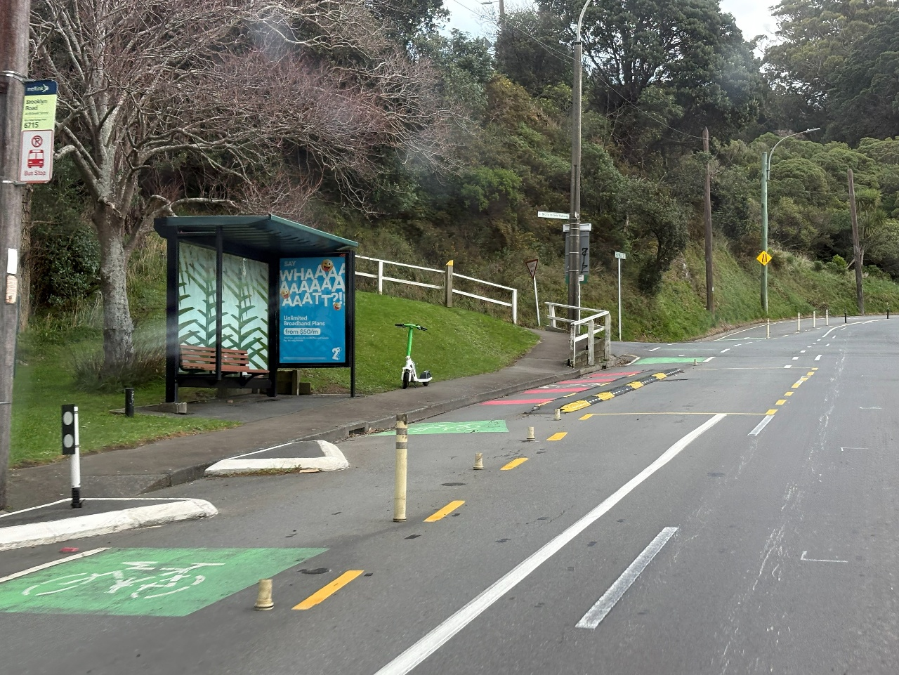
Stantec New Zealand

Rev | Description | Author | Date | Quality Check | Date | Review | Date
1 | Final | Cobus de Kock | 22/06/2026 | SSAT | 26/06/2026 | Jon England | 26/06/2026

The conclusions in the Report titled Brooklyn Hill Cycling Improvements Updated 90% Detailed Design SSA are Stantec’s professional opinion, as of the time of the Report, and concerning the scope described in the Report. The opinions in the document are based on conditions and information existing at the time the scope of work was conducted and do not take into account any subsequent changes. The Report relates solely to the specific project for which Stantec was retained and the stated purpose for which the Report was prepared. The Report is not to be used or relied on for any variation or extension of the project, or for any other project or purpose, and any unauthorized use or reliance is at the recipient’s own risk.
Stantec has assumed all information received from Wellington City Council (the “Client”) and third parties in the preparation of the Report to be correct. While Stantec has exercised a customary level of judgment or due diligence in the use of such information, Stantec assumes no responsibility for the consequences of any error or omission contained therein.
This Report is intended solely for use by the Client in accordance with Stantec’s contract with the Client. While the Report may be provided by the Client to applicable authorities having jurisdiction and to other third parties in connection with the project, Stantec disclaims any legal duty based upon warranty, reliance or any other theory to any third party, and will not be liable to such third party for any damages or losses of any kind that may result.
Prepared by | 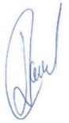
 | Signature
 | Cobus de Kock
 | Printed Name
Reviewed by | 
 | Signature
 | Jon England
 | Printed Name
Approved by
 | Signature
 | Cobus de Kock
 | Printed Name

Table of Contents
Acronyms / Abbreviations ii
1 Introduction 3
1.1 Road Safety Audit Definition and Purpose 3
1.2 The Project 4
1.3 The Safe System Audit Team 5
1.4 Briefing, Audit, and Exit Meetings 5
1.5 Previous Safe System Audits 5
1.6 Scope of this Safe System Audit 6
1.7 Report Format 6
1.8 Documents Provided 8
2 Safety Concerns 9
2.1 Brooklyn Road 9
2.1.1 Shared Path Markings at Washington Avenue Significant 9
2.1.2 Red Surfacing by the Bus Stop for the Shared Path Serious 10
2.1.3 Pedestrian Facilities at Brooklyn Road & Washington Avenue Intersection Significant 11
2.1.4 Missing Tactile Pavers Significant 13
2.1.5 Red Surfacing by the Bus Stop for the Shared Path Serious 15
2.2 Helen Street 16
2.2.1 Speed Hump Sign could be obscured by tree Significant 16
3 Audit Statement 18
4 Response and Decision Statements 19
4.1 Design Team's Responses 19
4.2 Safety Engineer's Comment (if applicable) 19
4.3 Client's Decisions 19
4.4 Safe System Audit Close Out 20

List of Tables
Table 1. Safety concern ranking 6
Table 2. Safety concern risk matrix 7
Table 3. Crash frequency as an indicator of probability 7

List of Figures
Figure 1: Site location 5
Figure 2: Drawing Sheet C303 – Shared Path Marking 9
Figure 3: Drawing Sheet C303 – Shared Path by The Bus Stop west of Washington Avenue 10
Figure 4: Drawing Sheet C303 - Pedestrian Facilities at Brooklyn Road & Washington Avenue Intersection 12
Figure 5: Drawing Sheet C302 - Missing Tactile Pavers 13
Figure 6: Drawing Sheet C302 – Shared Path by The Bus Stop north of Bidwill Street 15
Figure 7: Drawing Sheet C306 – Speed Hump Signs next to Vegetation 16

Acronyms / Abbreviations
RSA | Road Safety Audit
SSAT | Safe System Audit Team
SSA | Safe System Audit
WCC | Wellington City Council

Introduction

Road Safety Audit Definition and Purpose
A road safety audit is a term used internationally to describe an independent review of a future road project to identify any safety concerns that may affect the safety performance. The audit team considers the safety of all road users and qualitatively reports on road safety issues or opportunities for safety improvement.
A road safety audit is therefore a formal examination of a road project, or any type of project which affects road users (including cyclists, pedestrians, mobility impaired etc.), carried out by an independent competent team who identify and document road safety concerns.
A road safety audit is intended to help deliver a safe road system and is not a review of compliance with standards.
The primary objective of a road safety audit is to deliver a project that achieves an outcome consistent with Road to Zero and the Safe System approach, which is a safe road system free of death and serious injury. The road safety audit is a safety review used to identify all areas of a project that are inconsistent with a Safe System and bring those concerns to the attention of the client so that the client can make a value judgement as to appropriate action(s) based on the risk guidance provided by the safety audit team.
The key objective of a road safety audit is summarised as:
'to deliver completed projects that contribute towards a safe road system that is free of death and serious injury by identifying and ranking potential safety concerns for all road users and others affected by a road project.’
A road safety audit should desirably be undertaken at project milestones such as:
concept stage (part of business case),
scheme or preliminary design stage (part of pre-implementation),
detail design stage (pre-implementation or implementation), or
pre-opening or post-construction stage (implementation or post-implementation).
A road safety audit is not intended to be a technical or financial audit and does not substitute for a design check of standards or guidelines. Any recommended treatment of an identified safety concern is intended to be indicative only, and to focus the designer on the type of improvements that might be appropriate. It is not intended to be prescriptive and other ways of improving the road safety or operational problems identified should also be considered.
In accordance with the procedures set down in the NZTA Road Safety Audit Procedures for Projects Guidelines - Interim release May 2013 the audit report should be submitted to the client who will instruct the designer to respond. The designer should consider the report and comment to the client on each of any concerns identified, including their cost implications where appropriate, and make a recommendation to either accept or reject the audit report recommendation.
For each audit team recommendation that is accepted, the client will make the final decision and brief the designer to make the necessary changes and/or additions. As a result of this instruction the designer shall action the approved amendments. The client may involve a safety engineer to provide commentary to aid with the decision.
Decision tracking is an important part of the road safety audit process. A decision tracking table is embedded into the report format at the end of each set of recommendations. It is to be completed by the designer, safety engineer, and client for each issue, and should record the designer's response, client's decision (and asset manager's comments in the case where the client and asset manager are not one and the same) and action taken. Decision tracking of safety concerns ranked as a comment is optional.
A copy of the report including the designer's response to the client and the client's decision on each recommendation shall be given to the road safety audit team leader as part of the important feedback loop. The road safety audit team leader will disseminate this to team members.

The Project
Stantec were commissioned by Wellington City Council (WCC) to undertake the Safe System Audit (SSA) for the cycling improvements proposed as part of the Brooklyn Connections Cycleway project.
The project includes a more permanent uphill cycle lane on Brooklyn Road from lower Nairn Street, replacing the transitional trial cycle lane to Cleveland Street and new on street parking arrangements on Helen Street. This will be complemented with improvements for pedestrians, changes to improve bus journey times, a new shelter at one stop, and other safety improvements.
The SSA site and surrounding area are shown in Figure 1.
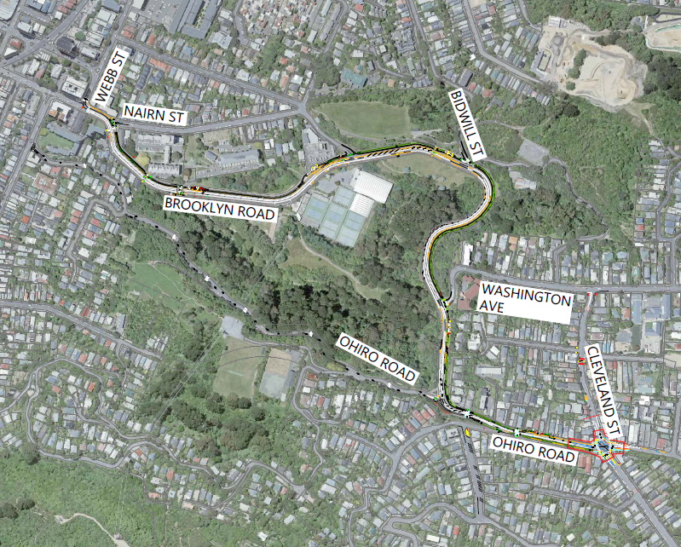
N
Figure 1: Site location

The Safe System Audit Team
This safe system audit has been carried out in accordance with the Waka Kotahi NZ Transport Agency Safe System Audit Guidelines for Transport Projects − Published in October 2022, by the following safe system audit team (SSAT):
- Cobus de Kock – Senior Principal Transportation Engineer & Traffic Engineering and Road Safety Lead (SSA Team Member)
- Jon England – Senior Principal Road Safety Engineer (SSA Team Leader)

Briefing, Audit, and Exit Meetings
No Briefing or exit meetings with the designer and Wellington City Council was held.

Previous Safe System Audits
The following safe system audits are relevant to this project.
Brooklyn Hill Cycling Improvements 50% Detailed Design Stage Safe System Audit
Brooklyn Hill Cycling Improvements 90% Detailed Design Stage Safe System Audit

Scope of this Safe System Audit
This is an updated 90% detailed design stage Safe System audit, which has been undertaken by the team named in Section 1.3.
This audit consisted of a daytime site visit that occurred on Thursday, 18th June 2026. This audit includes safety reviews of the documents provided by the Client, and an assessment of the site. A night time site visit was not undertaken for this audit as the SSAT were familiar with the site during the hours of darkness during the previous safe system audit. Weather conditions were overcast.

Report Format
    - Safety concern ranking
The safe system auditors have ranked the identified safety concerns together with four categories of suggested actions as shown in Table 1.
Table 1. Safety concern ranking
Ranking | Suggested action
Serious | A serious safety concern that must be addressed and requires changes to avoid serious safety consequences.
Significant | A significant safety concern that should be addressed and requires changes to avoid serious safety consequences.
Moderate | A moderate safety concern that should be addressed to improve safety.
Minor | A minor safety concern that could be addressed where practical to improve safety.

The ranking of safety concerns is based on the probability of a crash combined with the most likely severity outcome of that crash, as indicated in Table 2.

Table 2. Safety concern risk matrix
 |  | Severity Outcome
 |  | Non-injury | Minor | Safe System Injury Threshold | Serious | Fatal
 |  | Property damage only (PDO). | Injury that is not serious but requires first aid, or that causes discomfort or pain to the person injured. | Safe System Injury Threshold | Injury (fracture, concussion, severe cuts, or other injury) requiring medical treatment or removal to and retention in hospital. | Death occurring as the result of injuries sustained in a crash within 30 days of the crash.
Probability of a crash | Very likely | Minor | Moderate | Safe System Injury Threshold | Serious | Serious
Probability of a crash | Likely | Minor | Moderate | Safe System Injury Threshold | Serious | Serious
Probability of a crash | Unlikely | Minor | Minor | Safe System Injury Threshold | Significant | Serious
Probability of a crash | Very unlikely | Minor | Minor | Safe System Injury Threshold | Significant | Significant
Qualitative risk ranking requires professional judgement and a wide range of experience in projects of all sizes and locations. Factors that have been considered when qualitatively assessing the probability of a crash and the most likely severity outcome of that crash are described below.

Probability of a crash
The safe system auditors have drawn on historic crash rates or other research for similar elements of projects, or projects as a whole where appropriate, to assist in understanding the likely crash types, frequency, and likely severity that may result from a particular safety issue.
The probability of a crash in Table 2 has been qualitatively assessed on the basis of expected exposure (how many road users will be exposed to a safety issue) and the risk of a crash resulting from the presence of the issue.
It is sometimes helpful to use crash frequency as a surrogate indicator of crash probability as shown in Table 3.
Table 3. Crash frequency as an indicator of probability
Crash Frequency | Crash Probability
Multiple crashes (more than one per year) | Very likely
1 every 1 to 5 years | Likely
1 every 5 to 10 years | Unlikely
Less than 1 every 10 years | Very unlikely

Severity outcome
A crash of a particular type can result in a range of severity outcomes for the people involved. For the purposes of this assessment, the crash severity outcome in Table 2 has been qualitatively assessed as being the most likely or predominant severity outcome on the basis of factors such as speed, type of crash, type of vehicles, and the people likely to be involved.
The severity of an injury is determined in part by the ability of a person to tolerate the crash forces. A person wearing safety restraints in a modern motor vehicle will have a greater tolerance to the forces involved than a pedestrian or cyclist struck by a motor vehicle. The safe system auditors have also considered the likely user composition, and hence the likely severity of injury to the people involved in the crash. An able-bodied adult may have a greater ability to recover from higher trauma injuries than a child, whereas an elderly person may have poor ability to recover from high trauma injuries.
    - Comments
In addition to the ranked safety issues, it may be appropriate for the Safe System audit team to provide additional comments with respect to items that may have a safety implication but lie outside the scope of the Safe System audit. A comment may include items where the safety implications are not yet clear due to insufficient detail for the stage of project, and items outside the scope of the audit such as existing issues not impacted by the project or an opportunity for improved safety but not necessarily linked to the project itself. While typically comments do not require a specific recommendation, the auditors may give suggestions in some instances.
Decision tracking of safety concerns ranked as a comment is optional.
.

Documents Provided
The following documents were provided to the SSAT for the audit.
- Brooklyn Hill Cycling Improvements Detailed Design – 260603-1003220-Brooklyn-For ConsultationTR_C_Plans.pdf

Safety Concerns

Brooklyn Road

Shared Path Markings at Washington Avenue Significant
On drawing C303 the footpath and cycle way join on the western side of Washington Avenue (shown in Figure 2). There are no shared path markings or signage shown at this location in the provided plans. It is critical that to inform users that they are in a shared space to ensure that cyclists give way to pedestrians.
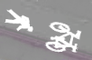
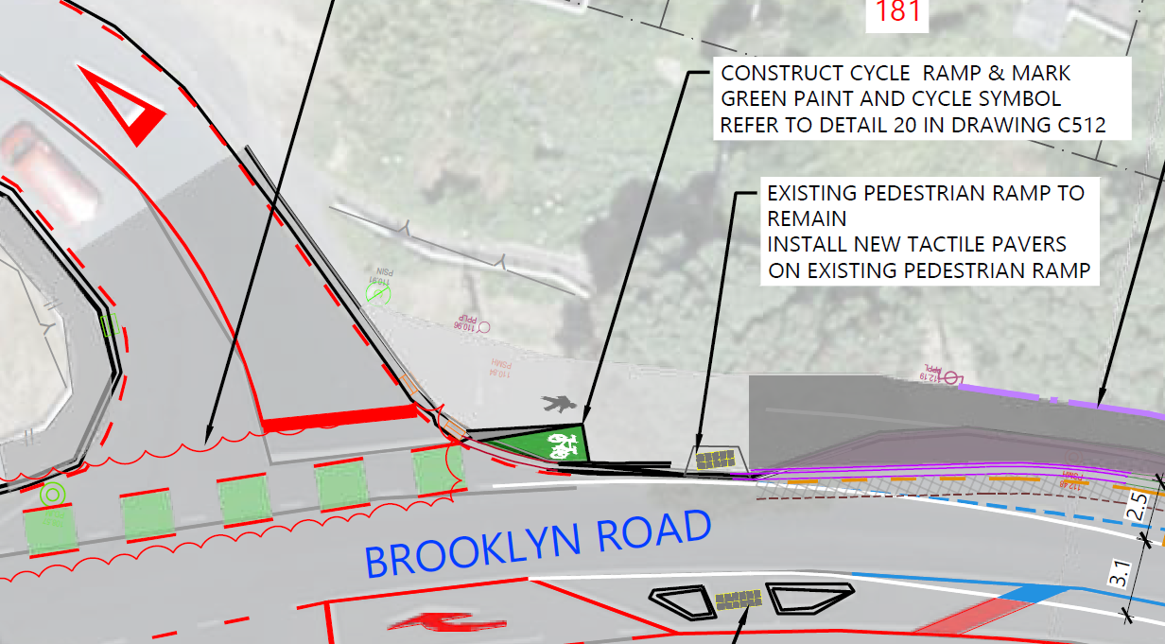
Figure 2: Drawing Sheet C303 – Shared Path Marking

Risk Ranking
The safe system audit team has assigned the following risk ranking to this safety concern.

Probability of a crash | Crashes resulting from this safety concern are unlikely.
Severity outcome rating | The predominant outcome of a crash resulting from this safety concern is likely to be serious.
Risk ranking | The safety concern is therefore deemed to be significant.

Recommendation(s)
- Apply road marking and signage at the start of the shared space to inform users that they are entering a shared path space.

Decision Tracking
Design team response | Agreed. Shared Path signs with supplementary “Begins” and “Ends” can be added at the start and end of the shared path, along with additional pavement markings to clearly inform users that they are entering a shared path.
Client safety engineer comment | Agree with Designer’s response.
Client decision | Agree with Designer and Client SE response
Action taken | An instruction will be issued to the designer to incorporate the required changes into the detailed design phase.

Red Surfacing by the Bus Stop for the Shared Path Serious
On drawing sheet C303, a shared path for pedestrians and cyclists is shown adjacent to the bus stop west of Washington Avenue. However, the absence of the banded red surfacing to highlight potential interactions (as shown in Figure 3) may reduce awareness among users. Without this visual cue, cyclists may not anticipate pedestrians entering or exiting the bus, and pedestrians may not expect cyclists passing through the shared path. Previously the SSAT has been supplied with detailed design of the shared path section, this has not been provided in this set and the SSAT would like to highlight this to ensure that the banded red surfacing is installed in this shared path section next to the bus stop at the Bidwill Street intersection.

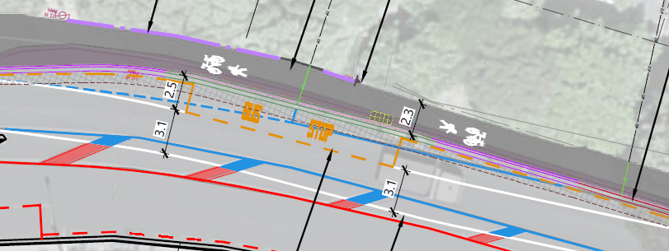
Figure 3: Drawing Sheet C303 – Shared Path by The Bus Stop west of Washington Avenue

Risk Ranking
The safe system audit team has assigned the following risk ranking to this safety concern.
The severity is based on reduced user awareness due to the absence of red surfacing at the shared path, increasing the risk of conflict between cyclists (particularly electric bikes travelling uphill at a faster speed) and pedestrians near the bus stop.
Probability of a crash | Crashes resulting from this safety concern are likely.
Severity outcome rating | The predominant outcome of a crash resulting from this safety concern is likely to be serious.
Risk ranking | The safety concern is therefore deemed to be serious.

Recommendation(s)
- Introduce banded red surfacing on the cycle path adjacent to the bus stop to warn cyclists of pedestrian activity.

Decision Tracking
Design team response | Agreed. The banded red surfacing pavement markings can be added on the shared path adjacent to bus stop.
Client safety engineer comment | Agree with Designer response.
Client decision | Agree with Designer and Client SE response
Action taken | An instruction will be issued to the designer to incorporate the required changes into the detailed design phase.

Pedestrian Facilities at Brooklyn Road & Washington Avenue Intersection Significant
On drawing sheet C303, a footpath is shown southeast of the intersection between Brooklyn Road and Washington Avenue (as shown in Figure 4). This footpath in the orange circle could direct pedestrians to an area that is a dead end and then create a situation where they try to cross the new cycleway, separator and Brooklyn Road where the red arrow is shown. Furthermore Brooklyn Road does not have a safe median refuge in this area. This could place pedestrians in a dangerous crossing situation with tripping hazards and the lack of a pedestrian refuge.
The safer place for pedestrians to cross Washington Avenue is at the green arrow and then they can use the dedicated pedestrian crossing point with median refuge island to then cross Brooklyn Road.
However the SSAT also noticed that there are no dropped kerbs provided on the footpaths on each side of Washington Avenue and it does not appear that drawing C303 makes provision for dropped kerbs or a crossing point. This could result in pedestrians tripping when crossing Washington Avenue, furthermore it will cause difficulty for visually impaired pedestrians as well as wheelchair users to cross Washington Avenue safely in this vicinity.
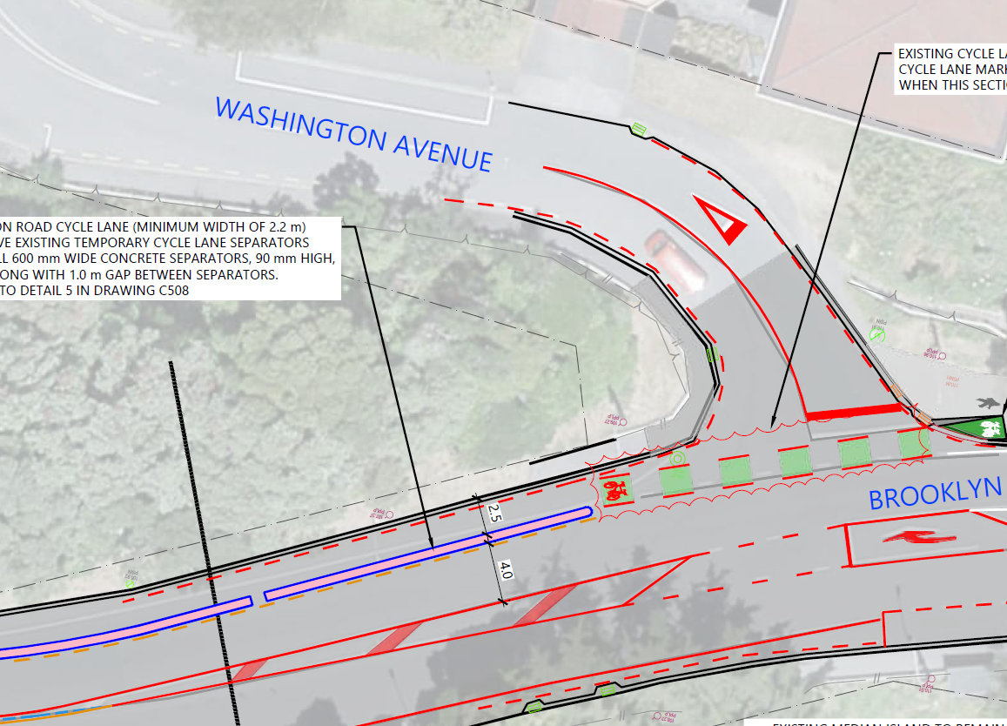
Figure 4: Drawing Sheet C303 - Pedestrian Facilities at Brooklyn Road & Washington Avenue Intersection

Risk Ranking
The safe system audit team has assigned the following risk ranking to this safety concern.
The severity is based on pedestrians crossing at undesignated locations due to misleading infrastructure, increasing the likelihood of unexpected vehicle-pedestrian conflict.
Probability of a crash | Crashes resulting from this safety concern are unlikely.
Severity outcome rating | The predominant outcome of a crash resulting from this safety concern is likely to be serious.
Risk ranking | The safety concern is therefore deemed to be significant.

Recommendation(s)
- Install dropped kerbs on Washington Avenue to provide a crossing point for pedestrians;
- Remove the footpath section shown in orange to prevent pedestrians becoming trapped and wanting to cross Brooklyn Road at the dead end; and
- Consider extending the sight rail where the blue line is shown to further direct pedestrians to utilise the safer crossing point on Brooklyn Road.

Decision Tracking
Design team response | Agreed. An informal pedestrian crossing (dropped kerbs on Washington Avenue) adjacent to the cycle lane crossing can be investigated. However, the provision of such a crossing is outside the current scope of this project.  Agreed. The section of footpath on Brooklyn Road leading to the dead end (highlighted in orange in the above image) can be removed to discourage pedestrians from becoming trapped and attempting to cross Brooklyn Road at the dead-end location.  Agreed. A fence can be added across the footpath leading to the dead end to guide pedestrians approaching from the northern Washington Avenue footpath to cross Washington Avenue and use the safer crossing point on Brooklyn Road.
Client safety engineer comment | Agree with Designer response,
Client decision | Agree with Designer and Client SE response
Action taken | An instruction will be issued to the designer to incorporate the required changes into the detailed design phase.  The informal pedestrian crossing (dropped kerbs on Washington Avenue), adjacent to the cycle lane crossing, will be referred to the maintenance team for consideration as part of future maintenance planning.

Missing Tactile Pavers Significant
On drawing sheet C302, on Brooklyn Road just north of the intersection with Bidwill Street, there is a pedestrian crossing point with tactile pavers on the footpath only (as shown in Figure 5), once the pedestrian has crossed the cycle way there is a small refuge before the bus entry taper. Due to the distance of the crossing past a refuge island this may create ambiguity for both visually impaired pedestrians not identifying the risk of stepping into the bus entry taper zone.

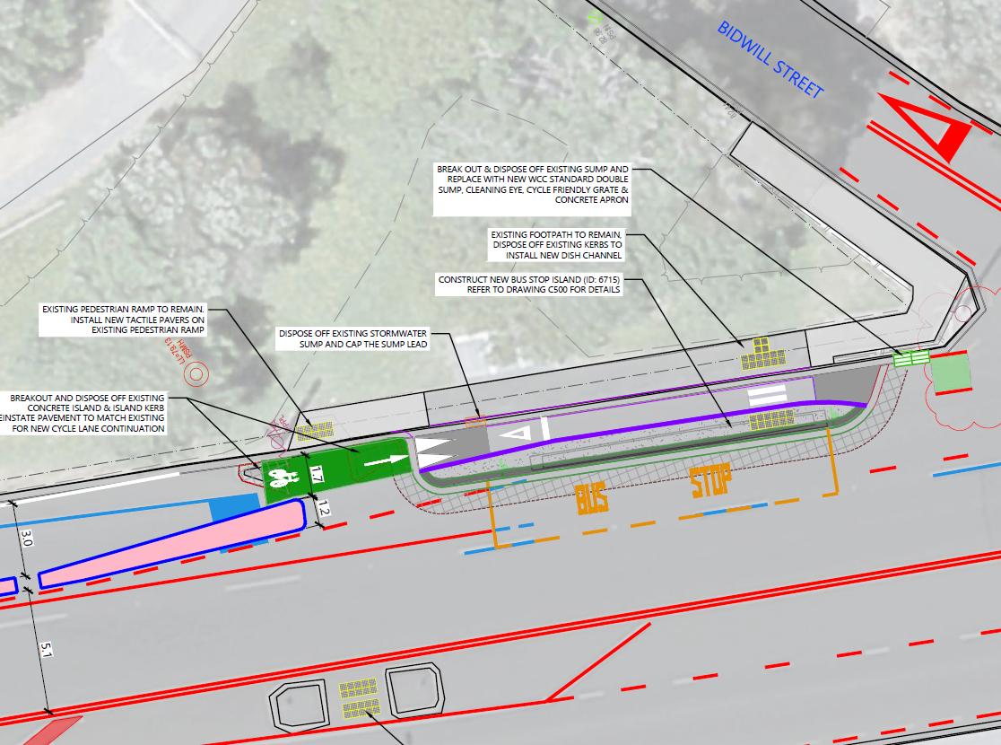
Figure 5: Drawing Sheet C302 - Missing Tactile Pavers

Risk Ranking
The safe system audit team has assigned the following risk ranking to this safety concern.
The severity is based on a visually impaired pedestrian being struck by a passing bus.
Probability of a crash | Crashes resulting from this safety concern are unlikely.
Severity outcome rating | The predominant outcome of a crash resulting from this safety concern is likely to be serious.
Risk ranking | The safety concern is therefore deemed to be significant.

Recommendation(s)
- Add additional warning tactile pavers.

Decision Tracking
Design team response | Agreed. Additional tactile pavers can be added at the location highlighted in the image above.
Client safety engineer comment | Agree with Designer response.
Client decision | Agree with Designer and Client SE response
Action taken | An instruction will be issued to the designer to incorporate the required changes into the detailed design phase.

Red Surfacing by the Bus Stop for the Shared Path Serious
On drawing sheet C302, a shared path for pedestrians and cyclists is shown adjacent to the bus stop north of Bidwill Street. However, the absence of red surfacing to highlight potential interactions (as shown in Figure 6) may reduce awareness among users. Without this visual cue, cyclists may not anticipate pedestrians entering or exiting the bus, and pedestrians may not expect cyclists passing through the shared path. Previously the SSAT has been supplied with detailed design of the shared path section, this has not been provided in this set and the SSAT would like to highlight this to ensure that the banded red surfacing is installed in this shared path section next to the bus stop at the Bidwill Street intersection.

Figure 6: Drawing Sheet C302 – Shared Path by The Bus Stop north of Bidwill Street

Risk Ranking
The safe system audit team has assigned the following risk ranking to this safety concern.
The severity is based on reduced user awareness due to the absence of red surfacing at the shared path, increasing the risk of conflict between cyclists (particularly electric bikes travelling uphill at a faster speed) and pedestrians near the bus stop.
Probability of a crash | Crashes resulting from this safety concern are likely.
Severity outcome rating | The predominant outcome of a crash resulting from this safety concern is likely to be serious.
Risk ranking | The safety concern is therefore deemed to be serious.

Recommendation(s)
- Introduce banded red surfacing on the cycle path adjacent to the bus stop to warn cyclists of pedestrian activity and ensure the white crossing line is flush with the surface to prevent trip hazards.

Decision Tracking
Design team response | The red pavement surfacing marking along the full length of the cycle bypass adjacent to the bus stop is already shown on Drawing C500 of the detailed design set, which was not included in the drawings provided to the SSAT.
Client safety engineer comment | Agree with Designer response.
Client decision | Agree with Designer and Client SE response
Action taken | No action is required as this has been addressed on another drawing.

Helen Street

Speed Hump Sign could be obscured by tree Significant
Drawing sheet C306 indicates that speed hump signs are to be installed at the new humps (as shown in Figure 7). The signs are proposed to be placed in proximity to existing trees, if such signs are not visible to approaching drivers it could cause them to not anticipate the vertical deflection in the road and this could lead to a loss of control and potential crash.
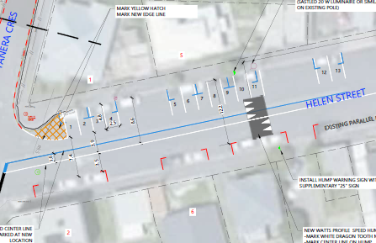
Figure 7: Drawing Sheet C306 – Speed Hump Signs next to Vegetation

Risk Ranking
The safe system audit team has assigned the following risk ranking to this safety concern.
The severity is based on reduced visibility of the signs due to existing trees, increasing the risk of drivers not seeing the signs and lose control at the speed humps if they don’t slow down sufficiently.
Probability of a crash | Crashes resulting from this safety concern are unlikely.
Severity outcome rating | The predominant outcome of a crash resulting from this safety concern is likely to be serious.
Risk ranking | The safety concern is therefore deemed to be significant.

Recommendation(s)
- Ensure signs are placed clear of vegetation.

Decision Tracking
Design team response | Agreed, the sign placement shall be to make sure that it is clear of vegetation. In addition to the signs, the speed humps are supplemented with raised hump pavement markings to enhance driver awareness of the presence of the speed hump.
Client safety engineer comment | Agree with Designer response.
Client decision | Agree with Designer and Client SE response
Action taken | This will be addressed with the contractor during the construction phase.

Audit Statement
We declare that we remain independent of the design team and have not been influenced in any way by any party during this road safety audit.
We certify that we have used the available plans, and have examined the specified roads and their environment, to identify features of the project we have been asked to look at that could be changed, removed, or modified to improve safety.
We have noted the safety concerns that have been evident in this audit and have made recommendations that may be used to assist in improving safety.

Signed |  | Date | 26/06/2025
Cobus de Kock, CPEng, BEng, MScEng, CMEngNZ, PrEng
Senior Principal Transportation Engineer / Traffic Engineer and Road Safety Lead, Stantec
Signed |  | Date | 26/06/2025
Jon England, BEng, CMEngNZ, CPEng, IntPE(NZ), RPEQ, PMP
Senior Principal Road Safety Engineer, Stantec

Response and Decision Statements
System designers and the people who use the roads must all share responsibility for creating a road system where crash forces do not result in death or serious injury.

Design Team's Responses
We have studied and considered the auditors' safety concerns and recommendations for safety improvements set out in this report and we have responded accordingly to each safety concern with the most appropriate and practical solutions and actions, which are to be considered further by the safety engineer (if applicable) and project manager.
Signed | 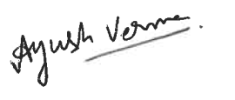 | Date | 29 June 2026
Ayush Verma,
Senior Civil Engineer,
Egis

Safety Engineer's Comment (if applicable)
I have studied and considered the auditors' safety concerns and recommendations for safety improvements set out in this report together with the designer's responses. Where appropriate, I have added comments to be taken into consideration by the project manager when deciding on the action to be taken.
Signed | 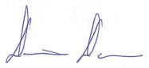 | Date | 2.07.2026
Dennis Davis,
Principal transport Engineer, WCC

Client's Decisions
I have studied and considered the auditors' safety concerns and recommendations for safety improvements set out in this report, together with the designer's responses and the comments of the safety engineer (if applicable) and having been guided by the auditor's ranking of concerns have decided the most appropriate and practical action to be taken to address each of the safety concerns.
Signed |  | Date | 6/07/2026
Ross Balfour
Manager Transport, Infrastructure & Operations- Wellington City Council

Safe System Audit Close Out
The project manager is to distribute the audit report incorporating the decisions to the designer, Safe System audit team leader, safety engineer, and project file.

Signed | 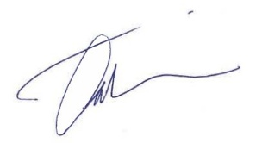 | Date | 6/07/2026
Michael Talebi
Project Manager
Wellington City Council



Stantec is a global leader in sustainable architecture, engineering, and environmental consulting. The diverse perspectives of our partners and interested parties drive us to think beyond what’s previously been done on critical issues like climate change, digital transformation, and future-proofing our cities and infrastructure. We innovate at the intersection of community, creativity, and client relationships to advance communities everywhere, so that together we can redefine what’s possible.

