Brooklyn Connections – Proposed Traffic Resolution
Brooklyn Connections aims to improve safety, accessibility and connectivity along the Brooklyn Road and Ohiro Road corridor. The project includes a range of changes to the road layouts, pedestrian facilities, public transport infrastructure and cycling connections.
In late June, Wellington City Council adopted the 2026-2027 Annual Plan which included the decision to proceed and consult with the community again about the Brooklyn Connections project. We would now like to get your feedback on the revised proposed changes.
This document outlines what is being proposed and how you can have your say. We encourage you to read the information below alongside the information on the website to understand the proposed changes and how they may affect your neighbourhood.
Consultation is open from Monday 13 July to Monday 3 August 2026.
Find out more at: transportprojects.org.nz/brooklyn-connections

Proposal:

Reference | - TR67-26 Brooklyn to City Improvements - Cycleway
Location – where we propose to make the change | We are proposing to make changes along Brooklyn Road and Ohiro Road (between Willis Street and Cleveland Street)
What we’d like to do | We propose to construct bike and bus infrastructure along Brooklyn Road and Ohiro Road to the intersection of Ohiro Road/Cleveland Street.  This project will result in changes to the way some areas of road and footpaths are currently used including:  - Removal of on-street parking  - Removal and relocation of bus stops  - New pedestrian zebra crossing at existing median refuge crossing outside property #143B Ohiro Road.  Proposed summary of changes:  - Slight shift (shortening the bus stop box) at the bus stop (ID 6716), west of Washington Avenue/Brooklyn Road intersection  - Removal of bus stop (ID:6719) outside property #185 Ohiro Road  - Relocation of bus stop (ID:6718) from outside property #159A, Ohiro Road to outside property #171 Ohiro Road)  - Slight shift (shortening the bus stop box) at bus stop (ID 7718), opposite to Bretby Crescent  - Removal of roadside parking along Ohiro Road Southbound Lane 4 parking spaces (outside property #169, 171 and #175)  - Removal of roadside parking along Ohiro Road northbound lane 20 parking spaces (south of property #184 access and north of property #158 access)  - Removal of roadside parking along Ohiro Road northbound lane 5 parking spaces (north of the Tanera Crescent/Ohiro Road intersection)  - Removal of roadside parking along Brooklyn Road northbound lane 8 parking spaces (east of Ohiro Road/Brooklyn Road intersection)  - Installation of a flush pedestrian (zebra) crossing on Ohiro Road outside property #143  - Proposed cycle lane in southbound direction along Brooklyn Road from Nairn Street/Willis Street intersection to outside property #159A, Ohiro Road  - Proposed cycle lane in northbound direction from approx. 25m north from Cleveland Road/Ohiro Road intersection to opposite property #145, Ohiro Road  - Changes to 15 roadside parallel parking spaces to 33 90-degree angled parking spaces along Helen Street southern kerbline.
Why we are proposing the change | In 2021, Wellington City Council trialled a temporary uphill bike and scooter lane on Brooklyn Road through Waka Kotahi NZTA’s Innovating Streets programme. The trial was designed to test safer street layouts and gather community feedback before considering permanent changes.  Following public consultation in June and July 2023, Councillors approved a package of permanent walking, biking and bus improvements for the corridor.  Since then, the funding environment has changed significantly. The project has lost NZTA co-funding and funding available for Wellington's bike network programme was reduced. In response, we reviewed the design and looked for ways to retain the most important safety and accessibility improvements while reducing costs.  Because the proposal and scope has changed, we are engaging with the community for feedback before any further decisions are made.
Impact | Net parking impact:  - Permanent removal of 29 roadside unrestricted parking spaces along Ohiro Road  - Permanent removal of 8 roadside unrestricted parking spaces along Brooklyn Road northbound  - Permanent removal of 15 roadside parallel unrestricted parking spaces on Helen Street  - Addition of 33 90-degree angled unrestricted parking spaces on Helen Street.  Overall, the changes result in a net gain of 18 parking spaces on Helen Street and a net loss of 37 parking spaces along Ohiro Road and Brooklyn Road.  The Brooklyn Connections project will improve safety and accessibility for people who choose to walk along a key transport corridor and an important route in Wellington’s bike network. The proposed changes are designed to make it safer and easier for people travelling through the area by bike, scooter, on foot, and by bus.  New and upgraded pedestrian crossing facilities will improve access to bus stops, footpaths and cycle lanes, making it easier and safer for people to move through the area. Changes to bus stop locations and layouts will also help improve the efficiency of bus services.  By improving walking, cycling and public transport connections, the project supports safer, more accessible and lower-carbon travel choices for residents, commuters, students and visitors travelling through Brooklyn.
Other options considered | Option 1:  - Raised pedestrian zebra crossing along Brooklyn Road and Ohiro Road at existing pedestrian crossing. This option is not preferred as Brooklyn Road is a heavy vehicles route for vehicles going to the landfill sites.  Option 2:  - Various angles (45-degree, 60 degree) for Helen Street parking arrangements. The most efficient way of increasing the parking numbers on Helen Street is to install 90-degree parking.
How this relates to the parking policy | - Support shift in type of transport used – facilitate a shift to using active (eg walking and cycling) and public transport through parking management and pricing, to move more people driving fewer vehicles.  - Support safe movement – facilitate the safe and efficient movement of people and goods by focusing on people moving along transport corridors rather than people parking or storing stationary vehicles.  - Support move to becoming an eco-city – facilitate the uptake of car sharing, electric vehicles and other transport with low carbon emissions. Manage parking and incentivise a decrease in vehicle use to contribute to reduced carbon emissions, better water quality, air quality, stormwater management and biodiversity outcomes.
Additional Information | The project objective of this investment is that by the completion date, Wellington City Council delivers good quality and safe multi-modal transport infrastructure for all road users on this route to Brooklyn. The work is fully aligned with the bike network plan and other Council objectives.  The Bus Priority Action Plan identified there are 3500 bus passengers on this route daily  - Average daily cycle count – 164  - Average daily traffic count – on Ohiro Road (between Tanera Crescent and Todman Street), the 7-day average daily traffic count in both directions is 12,695 vehicles per day.  - 41 crashes have been recorded in the NZTA Crash Analysis database over the last five years along the Brooklyn Road and Ohiro Road section, including 20 were injury crashes.
Privacy | - Your privacy is important to us. Please DO NOT add specific personal details to your feedback (ie full name, address, etc).  - What we do with your personal information:  All submissions (including your first name, but not contact details) are provided in their entirety to elected members and made available to the public on our website and at our office. Personal information (including contact details) will also be used for the administration of the consultation process including informing you of the outcome of the consultation. All information collected will be held by Wellington City Council, with submitters having the right to access and correct personal information.  - For more information regarding our privacy statement please check our webpage: Privacy statement - Wellington City Council.
Feedback | - Have your say. We’d like to hear what you think.  - To find out more about the project and to provide feedback via the online form go to https://www.transportprojects.org.nz/brooklyn-connections  - Feedback is open from 9 on Monday 13 July and finishes at 5pm on Monday 3 August 2026.  - You can email your feedback to us at citydesignprojects@wcc.govt.nz  - If you have any questions about the proposed changes, or need help making a submission, chat to the team at a drop-in session:  - Saturday 25 July 2026  From 11am to 2pm  Brooklyn Community Centre, 18 Harrison street, Brooklyn  - Tuesday 28 July 2026  From 5pm to 7pm  Two Todman, 2 Todman Street, Brooklyn  - All feedback will be handled in line with our privacy policy for submissions: https://www.transportprojects.org.nz/why/privacy
Next Steps | - Feedback will be collated by 18 September 2026.  - The proposal will go to the Te Takere|Regulatory Processes Committee meeting on 7 October 2026.  - If approved, work to install the changes is expected to begin in early 2027.

Traffic Resolution Overall Plan: TR67-26 Brooklyn to City Improvements - Cycleway
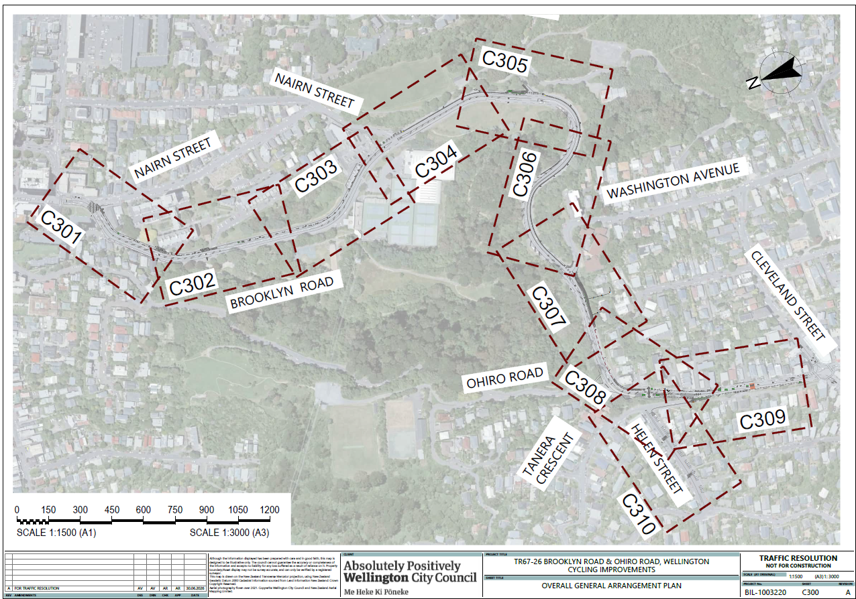
Traffic Resolution Plan 1: TR67-26 Brooklyn to City Improvements - Cycleway
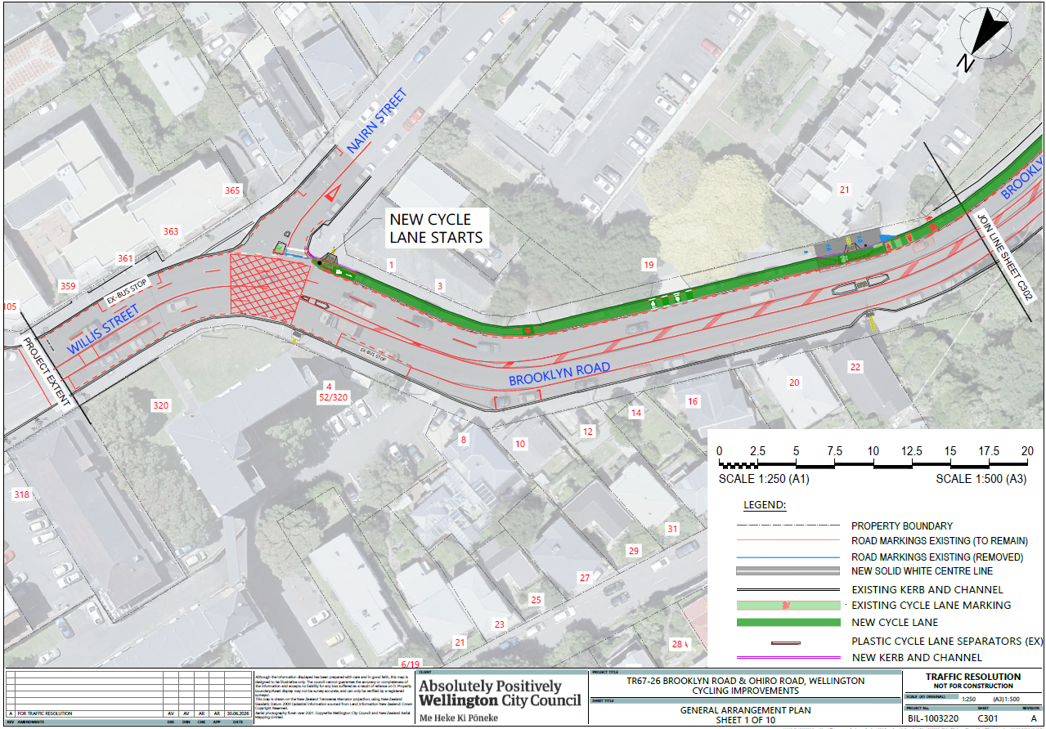
Traffic Resolution Plan 2: TR67-26 Brooklyn to City Improvements - Cycleway
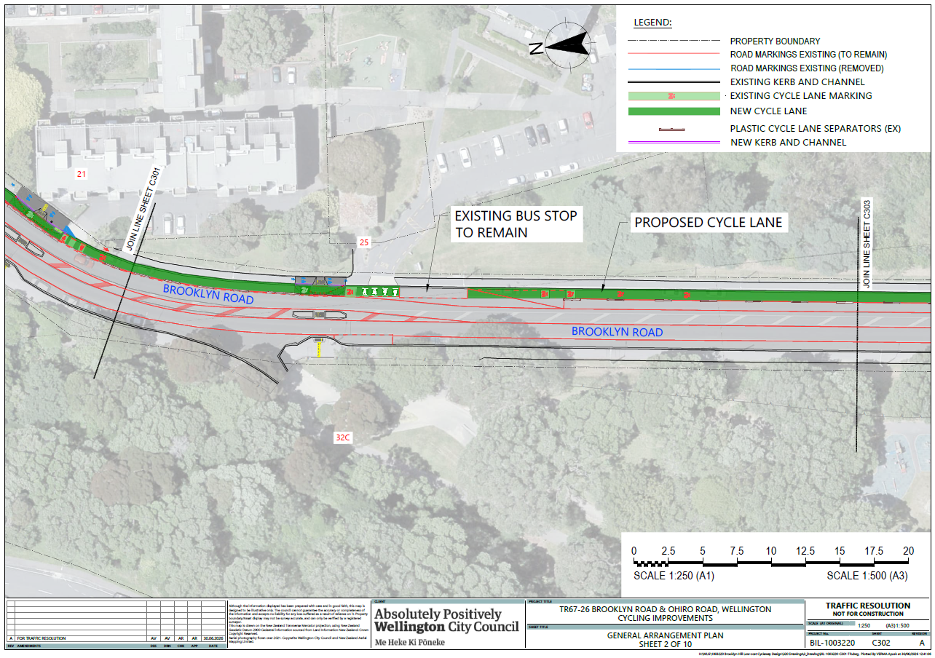
Traffic Resolution Plan 3: TR67-26 Brooklyn to City Improvements - Cycleway

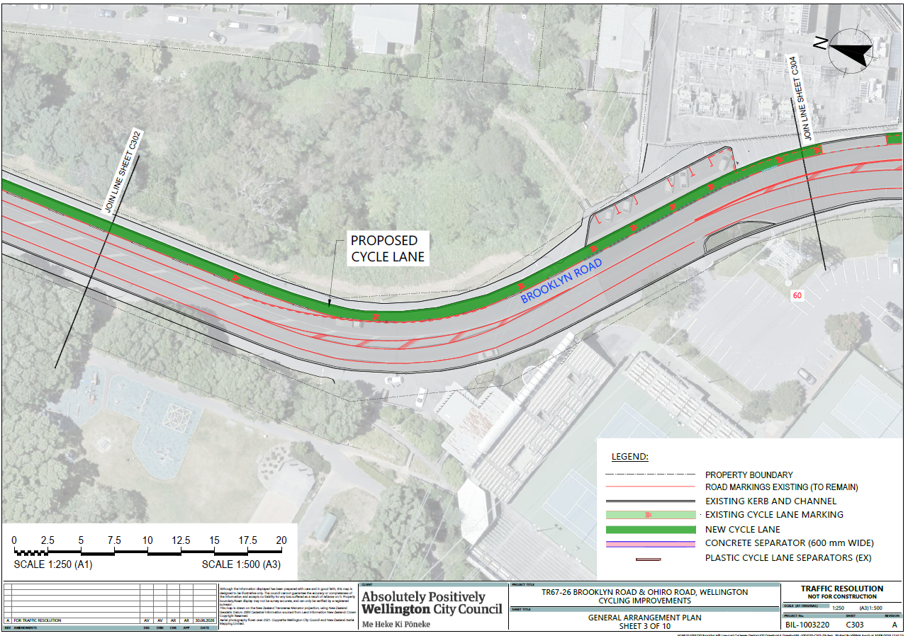
Traffic Resolution Plan 4: TR67-26 Brooklyn to City Improvements - Cycleway
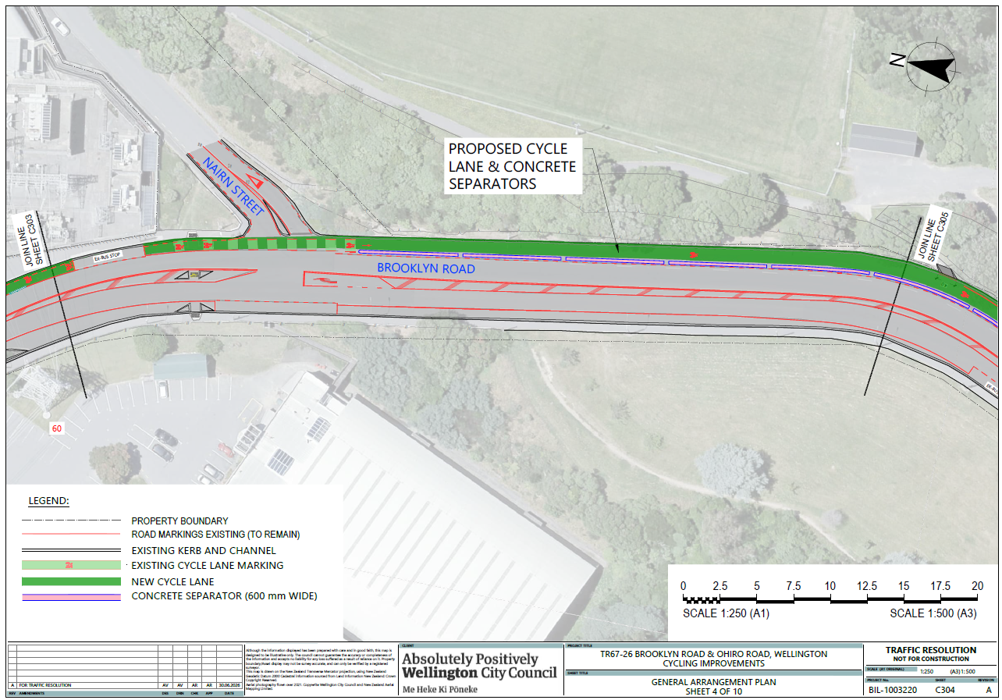
Traffic Resolution Plan 5: TR67-26 Brooklyn to City Improvements - Cycleway
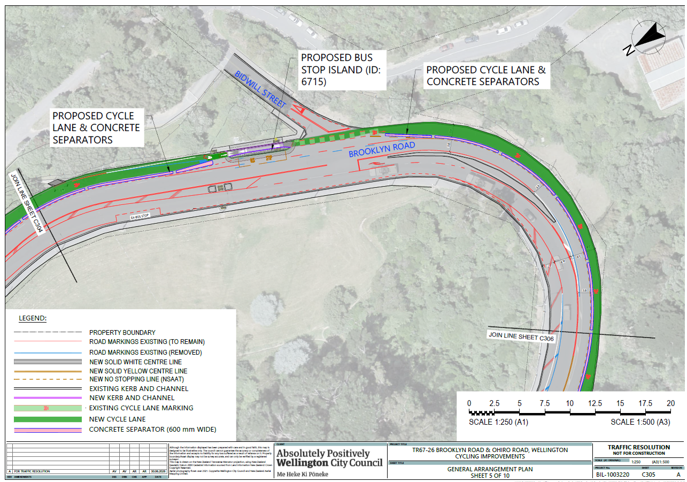
Traffic Resolution Plan 6: TR67-26 Brooklyn to City Improvements - Cycleway
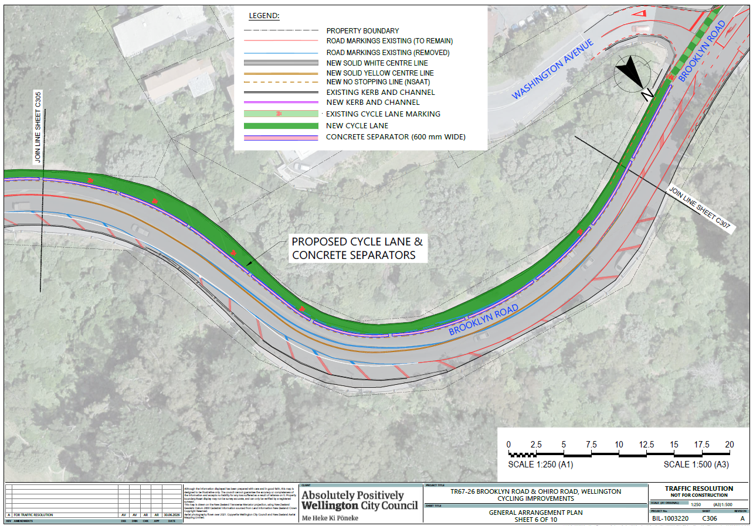
Traffic Resolution Plan 7: TR67-26 Brooklyn to City Improvements - Cycleway
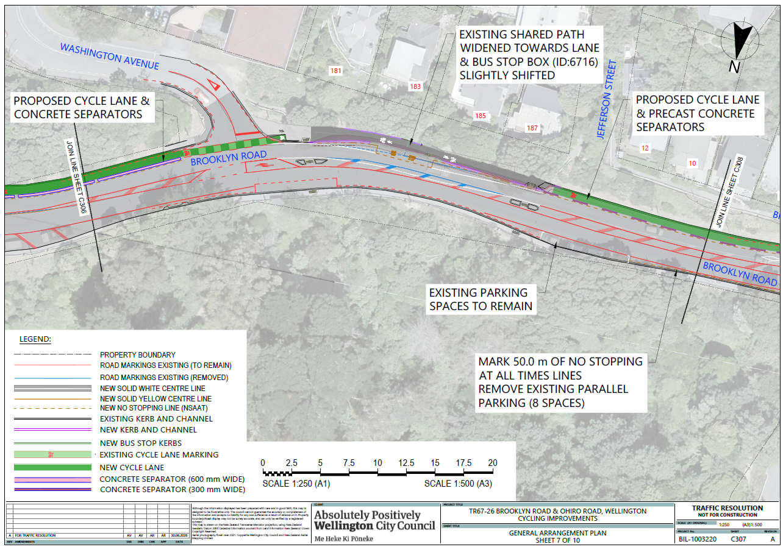
Traffic Resolution Plan 8: TR67-26 Brooklyn to City Improvements - Cycleway
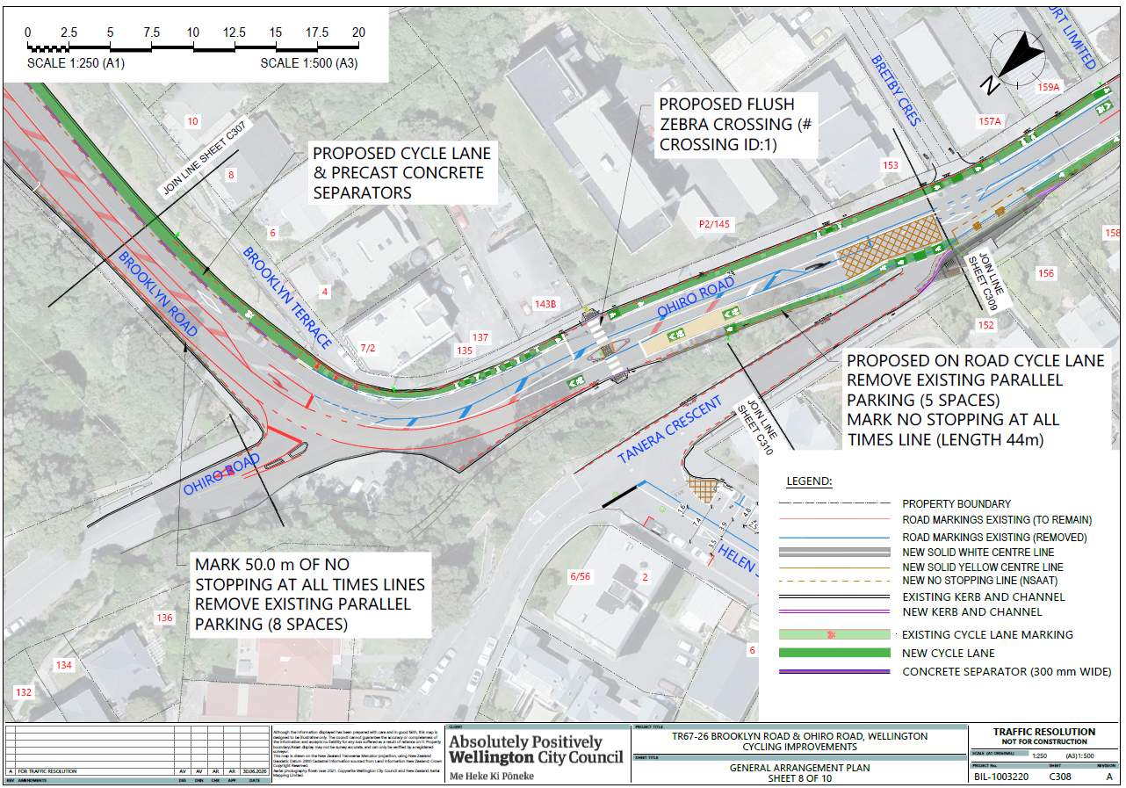
Traffic Resolution Plan 9: TR67-26 Brooklyn to City Improvements - Cycleway
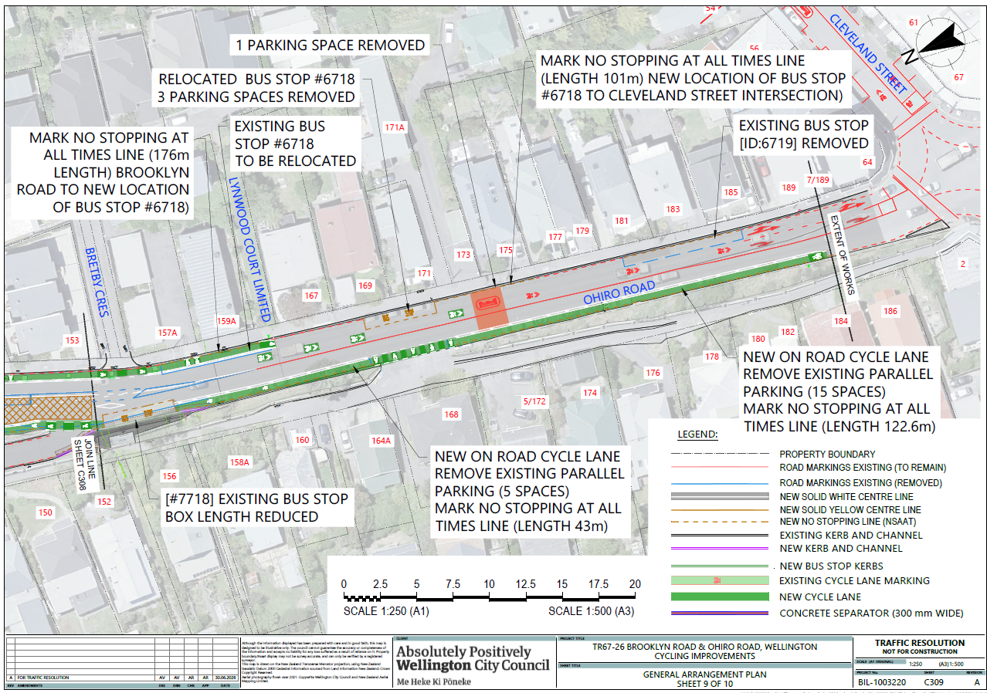

Traffic Resolution Plan 10: TR67-26 Brooklyn to City Improvements – Helen Street
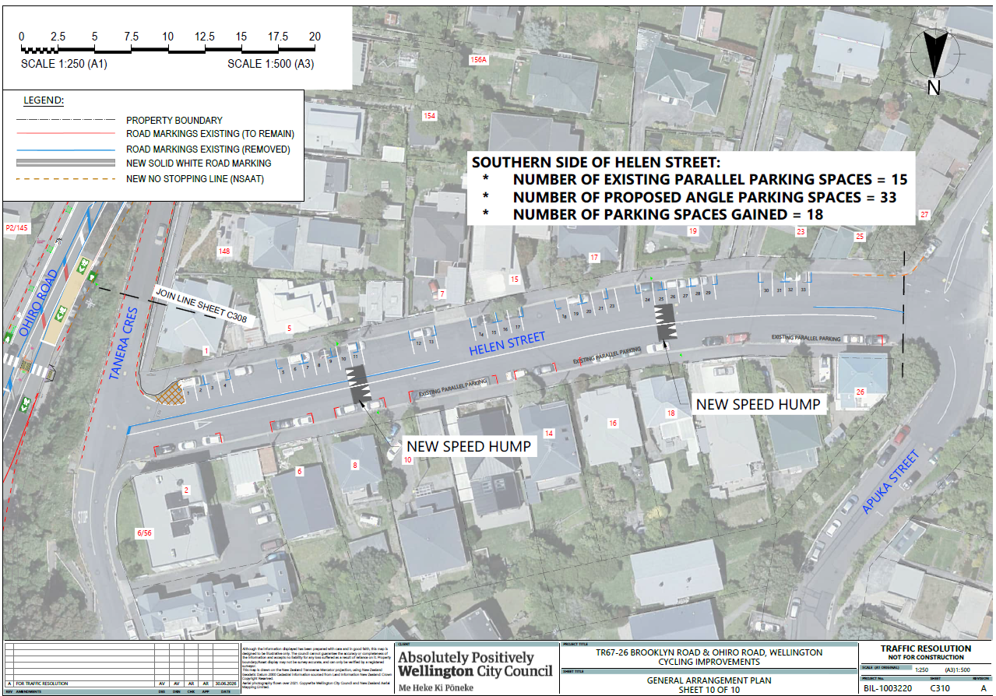
Legal Description:

Delete from Schedule B (Class Restricted) of the Traffic Restrictions Schedule

Column One | Column Two | Column Three
Brooklyn Road | Bus Stop, At All Times | South side, commencing 19 metres south of its intersection with Washington Avenue and extending in a westerly direction following the southern kerbline for 21 metres.
Ohiro Road | Bus Stop, At All Times | East side, commencing 126 metres south of its intersection with Brooklyn Road Bretby Crescent and extending in a southerly direction following the eastern kerbline for 15 metres.
Ohiro Road | Bus Stop, At All Times | East side, commencing 6.5 metres south of its intersection with Bretby Crescent and extending in a southerly direction following the eastern kerbline for 23 metres
Ohiro Road | Bus Stop, At All Times | West side, commencing 11 metres south of its intersection with Tanera Crescent (Grid Coordinates x=1747645 y=5426037m) and extending in a southerly direction following the western kerbline for 39 metres

Delete from Schedule D (No Stopping) of the Traffic Restrictions Schedule

Column One | Column Two | Column Three
Ohiro Road | No Stopping At All Times | East side, commencing from its intersection with Bretby Crescent and extending in an southerly direction following the eastern kerbline for 6.5 metres
Ohiro Road | No Stopping At All Times | East side, commencing 20m south of its intersection with Brooklyn Road (Grid Coordinates x=1747692 y=5426125m) and extending in a southerly direction following the eastern kerbline for 12 metres
Ohiro Road | No Stopping At All Times | East side, commencing 30m south of its intersection with Brooklyn Road (Grid Coordinates x=1747692 y=5426125m) and extending in a southerly direction following the eastern kerbline for 89 metres
Ohiro Road | No Stopping At All Times | East side, commencing 159m south of its intersection with Brooklyn Road (Grid Coordinates x=1747692 y=5426125m) and extending in a southerly direction following the eastern kerbline for 39 metres
Ohiro Road | No Stopping At All Times | East side, commencing 144 meters east of its intersection with Bretby Crescent and extending in a southerly direction following the eastern kerbline for 14 metres to its intersection with Cleveland Street
Ohiro Road | No Stopping At All Times | West side, commencing 4 metres north of its intersection with Todman Street (Grid coordinates, x= 1747605.7490 m, y= 5425848.9964 m) and extending in a northerly direction following the western kerbline for 21 metres.
Brooklyn Road | No Stopping At All Times | North side, commencing from its  intersection with Ohiro Road (Grid  coordinates x=1747704.9m,  y=5426145.1m), and extending in an  easterly direction following the northern  kerb line for 30 metres.

Delete from Schedule H (Pedestrian Crossings) of the Traffic Restrictions Schedule

Column One | Column Two | Column Three
Ohiro Road | Pedestrian Crossing - At All Times | Commencing 60 metres south of its intersection with Brooklyn Road (Grid Coordinates x = 1747692 y = 5426125 m)

Delete from Schedule I (Cycle Lane, Shared Path) of the Traffic Restrictions Schedule

Column One | Column Two | Column Three
Brooklyn Road | Cycleway - At All Times | South side, commencing 11 metres south of its intersection with Narin Street (Grid coordinates x=1748194m, y= 5426724m) and extending in a southerly direction following the southern kerbline for 163 metres
Brooklyn Road | Cycleway - At All Times | East side, commencing 184 metres south of its intersection with Narin Street (Grid coordinates x=1748194m, y= 5426724m) and extending in a southerly direction following the eastern kerbline for 120 metres
Ohiro Road | Cycleway - At All Times | East side, commencing 21 metres south of its intersection with Brooklyn Road (Grid coordinates x=1747692m, y= 5426125m) and extending in a southerly direction following the eastern kerbline for 13 metres
Ohiro Road | Cycleway - At All Times | East side, commencing 28 metres south of its intersection with Brooklyn Road (Grid coordinates x=1747692m, y= 5426125m) and extending in a southerly direction following the eastern kerbline for 89 metres
Ohiro Road | Cycleway - At All Times | East side, commencing 128 metres south of its intersection with Brooklyn Road (Grid coordinates x=1747692m, y= 5426125m) and extending in a southerly direction following the eastern kerbline for 64 metres
Ohiro Road | Cycleway - At All Times | West side, commencing 31 metres north of its intersection with Tanera Crescent (Grid coordinates x=1747645m, y= 5426037m) and extending in a southerly direction following the western kerbline for 43 metres
Ohiro Road | Cycleway - At All Times | West side, commencing 27 metres north of its intersection with Tanera Crescent (Grid coordinates x=1747645m, y= 5426037m) and extending in a southerly direction following the western kerbline for 8 metres
Ohiro Road | Cycleway - At All Times | West side, commencing 44 metres north of its intersection with Tanera Crescent (Grid coordinates x=1747645m, y= 5426037m) and extending in a southerly direction following the western kerbline for 139 metres

Add to Schedule B (Class Restricted) of the Traffic Restrictions Schedule

Column One | Column Two | Column Three
Brooklyn Road (near Washington Avenue/Brooklyn Road intersection) | Bus Stop At All Times | Southwest side, commencing 27 metres west of its intersection with Washington Avenue (Grid coordinates, x= 1747863.3438 m, y= 5426126.6633 m), and extending in a westerly direction following the southern kerbline for 15 metres.
Ohiro Road (Opposite to Bretby Crescent) | Bus Stop At All Times | West side, commencing 170 metres north of its intersection with Todman Street (Grid coordinates, x= 1747603.9622 m, y= 5425845.2974 m) and extending in a northerly direction following the western kerbline for 15 metres.
Ohiro Road (Outside property #171) | Bus Stop At All Times | Southeast side, commencing 46.5 metres south of its intersection with Bretby Crescent (Grid coordinates, x= 1747649.5201 m, y= 5426014.1776 m) and extending in a southerly direction following the eastern kerbline for 15 metres.

Add to Schedule D (No Stopping) of the Traffic Restrictions Schedule

Column One | Column Two | Column Three
Brooklyn Road (at its intersection with Ohiro Road) | No Stopping At All Times | North side, commencing from its intersection with Ohiro Road (Grid Coordinates x = 1747705.3300 y = 5426140.4405 m) and extending in a easterly direction following the northern kerbline for 62 metres.
Ohiro Road (at its intersection with Brooklyn Road) | No Stopping At All Times | East side, commencing from its intersection with Brooklyn Road (Grid Coordinates x = 1747705.3300 y = 5426140.4405 m) and extending in a northerly direction following the eastern kerbline for 7 metres.
Ohiro Road (Ohiro Road/ Brooklyn Road Intersection to bus stop outside property #169) | No Stopping At All Times | Southeast side, commencing from its intersection with Brooklyn Road (Grid coordinates x=1747708.1406m, y= 5426124.1956m), extending in a southerly direction following the eastern kerbline for 176 metres.
Ohiro Road (outside property #157 to Cleveland Road/Ohiro Road intersection) | No Stopping At All Times | Southeast side, commencing 191 metres south of its intersection with Brooklyn Road (Grid coordinates x=1747708.1406m, y= 5426124.1956m), extending in a southerly direction following the eastern kerbline for 101 metres.
Ohiro Road (Northbound lane - Todman Street/Ohiro Road intersection to bus stop ID 7718) | No Stopping At All Times | West side, commencing from its intersection with Todman Street (Grid coordinates, x= 1747605.7490 m, y= 5425848.9964 m) and extending in a northerly direction following the western kerbline for 166 metres.
Ohiro Road (Northbound lane - Tanera Crescent/Ohiro Road intersection to proposed zebra crossing) | No Stopping At All Times | West side, commencing from its intersection with Tanera Crescent (Grid coordinates, x= 1747646.5888 m, y= 5426037.8687 m) and extending in a northerly direction following the western kerbline for 44 metres.
Tanera Crescent (at its intersection with Ohiro Road) | No Stopping At All Times | West side, commencing from its intersection with Ohiro Road (Grid coordinates, x= 1747641.11 m, y= 5426029.18 m) and extending in a northerly direction following the western kerbline for 59 metres.

Add to Schedule H (Pedestrian Crossings) of the Traffic Restrictions Schedule

Column One | Column Two | Column Three
Ohiro Road (Outside property #143) | Pedestrian Crossing At All Times | Commencing 51 metres south of its intersection with Brooklyn Road (Grid Coordinates x = 1747700.0249 y = 5426129.9027 m)

Add to Schedule I (Cycle Lane, Shared Path) of the Traffic Restrictions Schedule

Column One | Column Two | Column Three
Brooklyn Road (Narin St/Willis st/Brooklyn Rd intersection to Bus stop outside #25) | Cycleway - At All Times | Southwest side, commencing from its intersection with Narin Street and Willis Street (Grid coordinates x=1748194.0597m, y= 5426725.6711m) and extending in a southerly direction following the eastern kerbline for 193 metres
Brooklyn Road (Bus stop outside #25 to Central park substation bus stop) | Cycleway - At All Times | Southwest side, commencing 208 metres south from its intersection with Narin Street and Willis Street (Grid coordinates x=1748194.0597m, y= 5426725.6711m) and extending in a southerly direction following the eastern kerbline for 256 metres
Brooklyn Road (Central park substation bus stop to east of Bidwill St bus stop) | Cycleway - At All Times | Southwest side, commencing 223 metres south from its intersection with Narin Street and Willis Street (Grid coordinates x=1748194.0597m, y= 5426725.6711m) and extending in a southerly direction following the eastern kerbline for 215 metres
Brooklyn Road (Bidwill St to Washington Avenue) | Cycleway - At All Times | Northeast side, commencing 6 metres north from its intersection with Bidwill Street (Grid coordinates x=1748133.7074m, y=5426095.1518m) and extending in a southerly direction following the eastern kerbline for 367 metres to its intersection with Washington Avenue
Brooklyn Road (West of Washington Avenue/Brooklyn Road intersection | Shared Path - At All Times | West side, commencing from its intersection with Washington Avenue (Grid coordinates x=1747865.0275m, y= 5426126.2171m), extending in a westerly direction following the southern kerbline for 75 metres
Brooklyn Road (West of Washington Avenue/Brooklyn Road intersection to Ohiro Road/Brooklyn Road intersection) | Cycleway At All Times | West side, commencing 75m west of its intersection with Washington Avenue (Grid coordinates x=1747865.0275m, y= 5426126.2171m), extending in a westerly direction following the southern kerbline for 83 metres.
Ohiro Road (west of Brooklyn Road intersection) | Cycleway At All Times | Southeast side, commencing from its intersection with Brooklyn Road (Grid coordinates x=1747708.1406m, y= 5426124.1956m), extending in an southerly direction following the eastern kerbline for 158 metres.
Ohiro Road (Northbound lane - Todman Street/Ohiro Road intersection to bus stop ID 7718) | Cycleway At All Times | West side, commencing 28 metres north of its intersection with Todman Street (Grid coordinates, x= 1747605.7490 m, y= 5425848.9964 m) and extending in a northerly direction following the western kerbline for 138 metres.
Ohiro Road (Northbound lane - Bus stop ID 7718 to proposed zebra crossing) | Cycleway At All Times | West side, commencing 181 metres north of its intersection with Todman Street (Grid coordinates, x= 1747605.7490 m, y= 5425848.9964 m) and extending in a northerly direction following the western kerbline for 45 metres.

Prepared By: | Michael Talebi | (Project Manager Street Transformation)
Approved By: | Ross Balfour | (Manager Transport Infrastructure & Operations)
Approved Date: | 29/06/2026

Letter Dropzone

