To  Jacob Wahry, Wellington City Council  From  Bridget Doran  subject  Bunny Street Cycleway Accessibility Investigations | summary  The memo was commissioned by Wellington City Council and has been prepared by transportation engineer and consultant Bridget Doran, with input from disability consultant Paul Brown, and CCS Disability Action accessibility advisor Raewyn Hailes.  It describes investigations into accessibility of proposed changes to Bunny Street, central Wellington. The proposal involves replacing some on-street parking on the northern side of Bunny Street with a bi-directional cycleway. The works extend to and include the intersections of Bunny Street with Featherston Street to the west, and Waterloo Quay to the east. Some changes to the road reserve on Lady Elizabeth Lane to meet the new cycleway are also proposed.  The purpose of this memo is to make constructive recommendations for changes to the proposal that will improve amenity and accessibility for all people, focusing on the needs of disabled pedestrians.  Recommendations are described on the following pages including snips from the developed design documents. A summary of recommendations is included on Page 7. The main recommendations with the most urgency for safety reasons are:  - At the Lady Elizabeth Lane approach to Waterloo Quay, move the proposed raised garden and e-scooter parking area to a defined and separated strip between the proposed cycleway and a building-edge footpath, to maintain an accessible path along the building edge  - At the Lady Elizabeth Lane approach to Waterloo Quay, paint the width of bi-directional cycleway where it begins some 8m from the kerb at the Waterloo Quay intersection crossing, to clearly separate shared space from separated cyclist and pedestrian paths  - Include hazard warning tactiles but not directional tactiles at the mid-block crossing on Bunny Street, to clarify its role as an optional, but not fully accessible crossing  - Remove the bus stop outside McDonalds, to improve visibility for pedestrians waiting to cross mid-block  - Increase pedestrian crossing time in the phasing for pedestrians crossing Waterloo Quay to Bunny Street, and across Bunny Street at Featherston Street

To improve accessibility and safety for this and future projects we recommend that Wellington City Council consider:
- A post-construction audit for this project
- A wayfinding audit from Wellington Railway Station to the waterfront
- A review of the ways that tactile indicators are used in Wellington, with a view to developing ‘wayfinding tactile’ approaches for blind people to navigate through shared public spaces.
Review commentary: benefits of the proposed designs
Overall, the proposed designs promote a more accessible and inclusive street than currently exists, by providing people riding bicycles a clear on-road lane. It will discourage cycling within the railway forecourt and on the Bunny Street footpath.
The designs have been carefully considered to promote safe access for everyone as far as possible. The intersections of Bunny Street with Featherston Street and Waterloo Quay are likely to be more accessible than before, because of the clarified spaces for cycles and pedestrians.
The design also discourages car traffic through Bunny Street through a reduction in on-street parking, and reallocation of space from private motor vehicles to walking and cycling. These are all benefits for the accessibility of everyone using these streets and provide positive messaging for those arriving at Wellington Station (by any transport mode) concerning the value of walking and cycling in Wellington.
Featherston street intersection, Bunny street and the proposed mid-block crossing
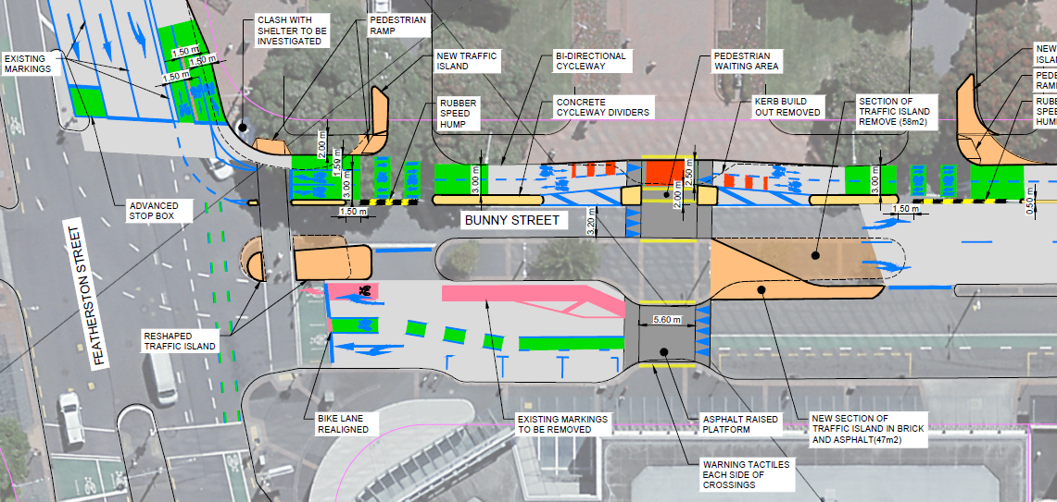
Figure 1 Developed design, Bunny Street including Featherston Street intersection and proposed mid-block crossing

The section of the project that includes the intersection with Featherston Street (Figure 1) is well-designed, with little to no negative impact on pedestrians. We recommend that the phasing is checked to ensure that it allows adequate time for pedestrians crossing the western end of Bunny Street, including time to cross the new cycleway.
The mid-block crossing has been designed to attract pedestrians heading towards the city centre from the train station. Currently pedestrians tend to cross all along Bunny Street. Therefore, the proposed formalized crossing is likely to improve safety and amenity for pedestrians.
As a step-free route, the crossing provides a new option for people who travel with mobility devices that have small wheels, and is likely to be convenient for many other pedestrians, including people pushing small children in prams. However, the crossing traverses the proposed bi-directional cycleway. It is not a priority crossing, so it is not as obvious to all people as a raised zebra crossing. We consider that this design is a good outcome, because there are safe, obvious, step-free crossings at both signalized intersections, approximately 100m to the left and right respectively.
Because of the complexity of the mid-block crossing environment (incorporating the cycleway), we do not recommend that directional tactiles are installed here. Rather, people who are blind or who have low vision ought to be encouraged to use the signalized crossings at either end of Bunny Street. We do recommend warning tactiles to alert any pedestrians to the hazard as they move from pedestrian space towards the cycleway and traffic lanes. All tactile indicators should comply with Council and national regulations including RTS14: Guidelines for facilities for blind and vision impaired pedestrians.
Given the project’s goal of encouraging cycle trips, and the high pedestrian volumes to and from the train station, it may be that additional pedestrian signals are warranted in this location. It is likely that some cyclists will be frustrated having to stop for crowds of pedestrians, which could induce conflict in what is not a formal pedestrian priority location. Mid-block signals may ultimately be warranted in this location. If that eventuates, we would recommend directional tactiles installed at that time.
The existing bus stop outside McDonalds on the southern side of Bunny Street is used by private buses including tour coaches. Buses are often parked there for hours at a time. These buses obscure visibility between pedestrians waiting to cross towards the station, and traffic headed west on Bunny Street. We recommend that the bus stop is shifted elsewhere on this block, in conversation with those who use it. Reconfiguration of parking and loading zones on this side of Bunny Street may mitigate this issue in the short-term. A P5 loading zone at this location would be an improvement over the bus stop, because of the length of time vehicles would likely park there.
We have no specific concerns with the remainder of Bunny Street. The cycleway separators are theoretical hazards for anyone crossing the street away from the three marked crossing locations, but people choosing to do that are likely to be aware of that risk and are not without other, safer options.
waterloo quay intersection and lady elizabeth lane
The design of Lady Elizabeth Lane approaching Waterloo Quay is largely an improvement on the existing situation because it begins to separate cyclists from pedestrians. We believe that this opportunity could be used to improve accessibility further. In particular, the strong building edge around the brick apartment building in this location provides a clear accessible route, so long as it is indeed clear.
We recommend that the phase for pedestrians to cross Waterloo Quay is lengthened from its current timing. There is not enough time for slower pedestrians to cross without time pressure. Given the high pedestrian volumes and strategic importance of this area as a pedestrian route, including to and from the ferry terminal and train station, a longer phase time is justified.
To promote separation of pedestrians and cyclists on Lady Elizabeth Lane we recommend moving the garden and e-scooter parking shown on the plan (Figure 2) to a concrete-separated strip between the cycleway and building edge. This would provide a safe, obvious, accessible route along and around the apartment building edge towards the footpath on the building’s eastern side.
The area at the intersection of Lady Elizabeth Lane and Waterloo Quay is inevitably a shared space because of the nature of the waterfront / train station environment. We recommend that the difference between shared and unshared paths are made more explicit. To that end, we recommend painting the cycleway in Lady Elizabeth Lane to mark the separated and shared zones. Without this marking we expect that more people will ride bicycles straight along the building edge, which is much better kept as an accessible walking route.
Despite these recommendations it is likely that many disabled people will find it difficult and intimidating to navigate between the intersection and the accessible path along Lady Elizabeth Lane. Therefore we recommend that tactile wayfinding guidance (e.g. directional tactiles) is installed between the building edge and the Waterloo Quay kerb. Without this guidance it is unlikely that a blind person unfamiliar with the area, or in a throng of pedestrians and cyclists, would be able to navigate. Further, wayfinding tactiles would alert other street users to the possible presence of a blind person, or others who cannot easily and comfortably move through spaces like this.
The flow of traffic through this part of central Wellington is likely to change after this project’s construction. We recommend monitoring in the immediate and longer-term aftermath, to review signal phasing so that pedestrian and cyclist levels of service (without unnecessary delay) are maintained.
Figure 2 Lady Elizabeth Lane approach to Waterloo Quay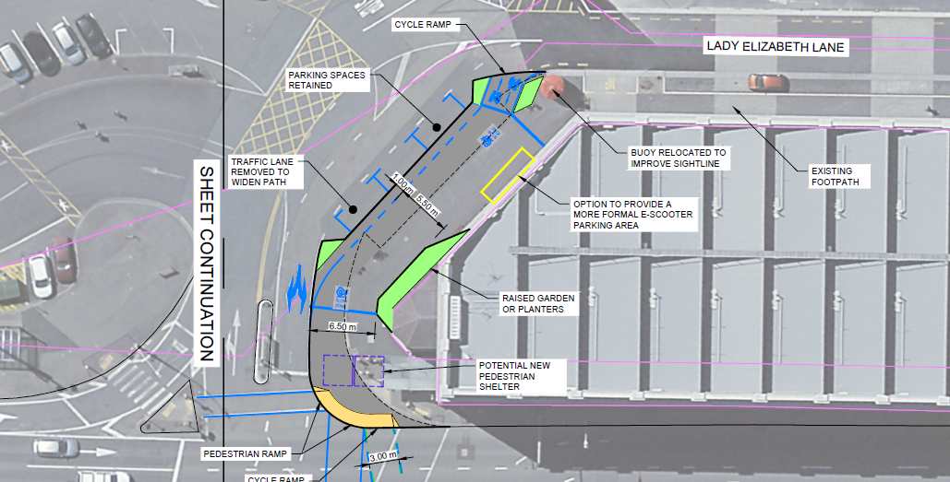
other recommendations
Post-construction audit
We recommend that an on-site audit is conducted with representatives from the contractor, Wellington City Council, and local disabled people, to identify any outstanding issues. The purpose of involving multiple stakeholders is so that the audit can double as training for the contractor to understand not just what is required, but why those details matter.
The role of tactiles for wayfinding
On New Zealand streets, tactile indicators are usually used for two reasons: to indicate a hazard, and to guide people towards a crossing location. We consider that a third use for tactiles may be beneficial: for wayfinding guidance through complex open spaces. The situation around Lady Elizabeth Lane is a good example of where a brief section of wayfinding tactile guidance would help people who are blind or who have low vision to quickly find the accessible path ‘through the mess’. Without any tactile guidance, busy street crossings that are designed to attract a mix of pedestrians and people riding scooters, cycles, and other devices are inherently intimidating and dangerous for blind people. Such situations cannot always be avoided in design, so we recommend that Wellington City lead a conversation about ways to mitigate their impact on the people who are otherwise excluded from these spaces.
Wayfinding audit between station and waterfront
The project promotes access for cyclists and pedestrians between central Wellington, in particular the train station, and the waterfront. The route is already popular and likely to increase in popularity as a result of this project. This is good, but there is high potential for anxiety and discomfort at the Lady Elizabeth Lane approach to Waterloo Quay. We expect that people who are familiar with the area, including disabled people, will decide for themselves whether to use this route or not. For many disabled people, they are likely to choose a different route to and from the waterfront once they are familiar with the busy interactions inherent at Lady Elizabeth Lane.
However, for people new to Wellington or to these streets, the potential for anxiety, discomfort, and collision with faster-moving people on cycles and other devices is real. We therefore recommend that a wayfinding audit is done for access between the waterfront and Wellington train station. Local disabled people will be best able to advise on how people might like to access information about their route options, including people newly arrived by train into Wellington. This could include local and domestic tourists, people visiting family or friends in Greater Wellington or traveling for work, and new migrants to the city. For a central train station in a capital city, a welcoming and inclusive first impression is important.
Closing Bunny Street to through-traffic
In the longer term, it seems logical to reclaim the section of Bunny Street between railway station accessways as pedestrian and cyclist space. As an entry point to the capital city, the station and its precinct attract a lot of pedestrians, including many new to the city. Their access and inclusion would be improved if through-traffic were removed from Bunny Street: pedestrians have no option but to exit the precinct somehow, whereas vehicular traffic has other ways to navigate this area.

Recommendations summary
Location | Recommendation | Response
Featherston Street / Bunny Street intersection | Review signal phasing to ensure enough time for all pedestrians to cross Bunny Street | WCCTOC to comment on length of late start for left turning vehicles
Bunny Street mid-block crossing | Include hazard warning tactiles but no directional tactiles | Agree with recommendation
Bunny Street mid-block crossing | Monitor the impact of pedestrian flows on cycleway operation: very high flows of both modes may warrant additional signals at this location | Agree with recommendation
Bunny Street mid-block crossing | Move the tour coach bus stop from the front of McDonalds to improve visibility at the proposed mid-block crossing | Can shorten the bus stop by 3m and extend build out that will provide clear sightline down Bunny St. Relocating bus stop is not feasible
Waterloo Quay / Bunny Street intersection | Increase the pedestrian signal phase for people crossing Waterloo Quay from Lady Elizabeth Lane to Bunny Street | WCCTOC to comment on length of late start for left turning vehicles
Waterloo Quay / Bunny Street intersection | Monitor signal phasing and delays at Waterloo Quay / Bunny Street in the month post-construction, and longer term, to adapt signal phasing to maintain pedestrian and cyclist levels of service | Agree with recommendation
Lady Elizabeth Lane | Move the garden and e-scooter parking to a concrete-separated strip between the cycleway and building edge, providing an accessible route along and around the apartment building edge | Building line is not accessible due to seating and building protrusions. Am not opposed to removing garden and escooter parking from the designs
Lady Elizabeth Lane | Paint the cycleway in Lady Elizabeth Lane to mark the separated and shared zones more explicitly | To consider as part of confirming layout option for this section
Lady Elizabeth Lane | Consider tactile wayfinding guidance (e.g. directional tactiles) between the building edge and Waterloo Quay kerb | Agree with recommendation
General | Conduct a post-construction audit | Noted
General | Conduct a wayfinding review for pedestrian access between the Wellington train station and waterfront | Noted
General | Consider and lead approaches to provide tactile wayfinding guidance through open public space to connect pedestrians between accessible routes | Noted
General | Consider pedestrianisation of the section of Bunny Street between station accessways. | Noted

Conclusion
We reiterate that as a whole, the project is likely to improve accessibility and amenity for everyone using this public space. With some minor changes and ongoing consideration, it could become a case study on how to promote the needs of all people as far as possible, within complex and constrained street environments.


Bridget Doran
Director

http://bridgetdoran.nz
bridget@bridgetdoran.nz
+64 22 0773831

